

Kingdom of Saudi Arabia

Ministry of Higher Education

Imam Abdulrahman Bin Faisal University

College of Computer Sciences & Information Technology

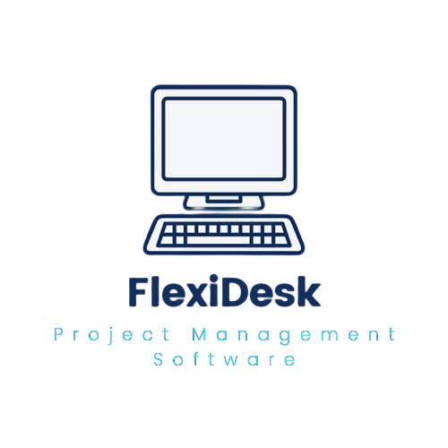**FlexiDesk**

A project submitted.

in partial fulfillment of the requirements for the degree of

Bachelor of Science in Computer Information Systems

**By**

**Abdulrahman A. Kateb 2210002045**

**Ammar M. Abduh 2210002324**

**Abdulaziz A. Shafae 2210002120**

**Salman M. Hassan 2210009060**

**Saud A. Alruzaiqi 2210001919**

**Supervised by**

**Dr. Saqib Saeed**

**Committee Member Names**

**Sardar Z. Iqbal**

**Aishah A. Al-Tamimi**

**December 2024**

**Declaration**

We hereby declare that this project report entitled **FlexiDesk** is a record of an original work done by us under the guidance of Supervisor Dr. Saqib Saeed, Associate Professor at College of CSIT, and that no part has been plagiarized without citations, which have been duly acknowledged. We also declare that it has not been previously or concurrently submitted for any other degree or award at any university or any other institution. This project work is submitted in the partial fulfillment of the requirements for the degree of “Bachelor of Science in Computer Information Systems” at Computer Information Systems Department, College of Computer Sciences and Information Technology, Imam Abdulrahman Bin Faisal University.

Project Team:

|  |  |  |
| --- | --- | --- |
| Group Number: 1 | | |
| Team Member’s Name | Signature | Date |
| Abdulrahman Kateb | *Abdulrahman* | 12/10/2024 |
| Ammar Abduh | *Ammar* | 12/10/2024 |
| Abdulaziz Shafae | *Abdulaziz* | 12/10/2024 |
| Salman Hassan | *Salman* | 12/10/2024 |
| Saud Alruzaiqi | *Saud* | 12/10/2024 |

**Acknowledgement**

We are incredibly grateful to Allah, the source of all knowledge and understanding, for providing us with the courage and guidance necessary to start and finish this difficult project. We also want to express deep appreciation to Dr. Saqib Saeed, our outstanding instructor, whose sound advice and valuable mentoring had a critical role in ensuring the success of our project. We also appreciate our college and its great faculty members for their continuous support and demanding instruction, which has significantly contributed to our academic development.

**Abstract**

**FlexiDesk** is a comprehensive web-based project management software that addresses common challenges faced by project managers and teams, such as miscommunication, time wastage, and disorganized systems. Designed around the five core phases of project management—Initiation, Planning, Execution, Monitoring and Controlling, and Closure—**FlexiDesk** offers real-time collaboration tools, an interactive whiteboard, an AI advisor, task tracking with progress bars, and generating report. By centralizing essential project management functions, the platform enhances productivity and communication, reduces turnaround times, and improves project success rates through real-time updates, collaboration features, and AI-driven recommendations.**Table of Contents**

List of Tables 14

LIST of Figures 16

1. Introduction 19

1.1. Introduction 19

1.2. Problem Statement 19

1.3. Background and Review of Literature 19

1.4. Motivation 22

1.5. Justification 23

1.6. Aims 23

1.7. Objectives 23

1.7.1. AI Advisor 23

1.7.2. View Options 24

1.7.3. Built-in Communication Platform 24

1.7.4. Progress Bar 24

1.7.5. Report Generator 24

1.7.6. Real-Time Collaboration 24

1.7.7. Centralized Management System 24

1.8. Scope / Limitation of the Study 24

1.9. Significance of The Study 25

1.10. Implications 25

1.10.1. Professional Implications 26

1.10.2. Ethical Implications 26

1.10.3. Social Implications 26

1.10.4. Security Implications 26

1.10.5. Legal Implications 26

1.11. Project Organization 27

1.11.1. Chapter 1 - Introduction 27

1.11.2. Chapter 2 - Software Project Management Plan (SPMP) 27

1.11.3. Chapter 3 - Requirements Specification (SRS) 27

1.11.4. Chapter 4 - Design Specification (SDS) 27

1.11.5. Chapter 5 - Implementation and Testing 27

1.11.6. Chapter 6 - Conclusion and external Participation 28

1.12. Chapter summary 28

2. Project Management Plan 29

2.1. Overview 29

2.1.1. Project Summary 29

2.1.1.1. Purpose 29

2.1.1.2. Scope 29

2.1.1.3. Objectives 29

2.1.1.4. Assumptions 30

2.1.1.5. Constraints 30

2.1.1.6. Project Deliverable 30

2.1.1.7. Master Schedule 32

2.1.1.8. Budget Summary 33

2.1.2. Evolution of the Plan 33

2.1.3. Document Structure 33

2.2. Project Organization 34

2.2.1. External Interfaces 34

2.2.2. Internal Structure 34

2.2.2.1. The Project Manager 34

2.2.2.1.1. Scope of Authority. 34

2.2.2.1.2. Scope of Responsibility. 35

2.2.2.1.3. Internal Responsibilities. 35

2.2.2.1.4. External Responsibilities. 35

2.2.3. Project Roles and Responsibilities 35

2.3. Management Process 35

2.3.1. Start-up 35

2.3.1.1. Estimation 36

2.3.1.2. Staffing Plan 37

2.3.1.3. Resource Acquisition 38

2.3.1.4. Staff Training 39

2.3.2. Work Planning 40

2.3.2.1. Work Activities 40

2.3.2.2. Schedule Allocation 41

2.3.2.3. Resource Allocation 41

2.3.2.4. Budget Allocation 44

2.3.3. Project Controls 45

2.3.3.1. Requirements Control 45

2.3.3.2. Schedule Control 45

2.3.3.3. Budget Control 45

2.3.3.4. Quality Control 45

2.3.3.5. Project Reporting and Communication 45

2.3.3.5.1. Electronic Media. 45

2.3.3.5.2. Meetings. 45

2.3.3.5.3. Information Repository. 45

2.3.3.5.4. Reviews. 45

2.3.3.5.5. Status Reporting. 46

2.3.4. Risk Management 46

2.3.5. Project Closeout 46

2.4. Technical Process 47

2.4.1. Process Model 47

2.4.2. Applicability of Technologies in Business Environments 48

2.4.3. Methods, Tools and Techniques 49

2.4.4. Project Infrastructure 49

2.4.5. Product Acceptance 50

2.5. Supporting Processes 50

2.5.1. Configuration Management 50

2.5.2. Independent Verification and Validation 50

2.5.3. Documentation 51

2.5.4. Quality Assurance 52

2.5.5. Reviews and Audits 52

2.5.6. Problem Resolution 52

2.5.7. Contractor Management 53

2.5.8. Process Improvement 53

2.5.8.1. Systems/Software Process Improvement Lead 53

2.5.8.2. Systems Engineering Process Group 53

3. Requirements Specification 54

3.1. Chapter Summary 54

3.2. Overall Description 54

3.2.1. Product Perspective 54

3.2.2. Product Functions 54

3.2.3. User Classes and Characteristics 55

3.2.4. Operating Environment 55

3.2.5. Design and Implementation Constraints 55

3.2.6. User Documentation 55

3.2.7. Assumptions 56

3.2.8. Dependencies 56

3.3. External Interface Requirements 56

3.3.1. User Interfaces 56

3.3.1.1. General interfaces 56

3.3.1.2. Project manager interfaces 56

3.3.1.3. Team member interfaces 57

3.3.2. Hardware Interfaces 57

3.3.3. Software Interfaces 57

3.3.4. Communications Interfaces 57

3.4. Use Case Diagram 58

3.5. System Features 58

3.5.1. Sign Up 58

3.5.2. Login 59

3.5.3. Reset Password 59

3.5.4. Task and Project Management 60

3.5.5. Real-Time Collaboration 60

3.5.6. Progress Tracking and Dashboards 61

3.5.7. Report generating 61

3.5.8. System Features: Notifications and Alerts 62

3.5.9. System Features: User Management 62

3.6. Other Nonfunctional Requirements 63

3.6.1. Performance Requirements 63

3.6.2. Safety Requirements 64

3.6.3. Security Requirements 64

3.6.4. Software Quality Attributes 64

3.6.5. Business Rules 65

4. Design Specifications 66

4.1. Chapter Summary 66

4.2. System Overview 66

4.3. Design Considerations 67

4.3.1. Assumptions and Dependencies 67

4.3.2. Constraints 67

4.3.3. Design Principles 68

4.4. User Interface Design 68

4.4.1. Overview of User Interface 68

4.4.1.1. General interfaces 68

*4.4.1.2.* Project manager interfaces 68

*4.4.1.3.* Team member interfaces 69

4.4.2. Interface Design Rules 69

4.4.3. interfaces mockup 69

4.4.3.1. General Interfaces 70

4.5. System Architecture 78

4.5.1. Architectural Design Approach 78

4.5.2. Architectural Design 78

4.5.2.1. Data Flow Diagram Level Zero 79

4.5.2.2. Data Flow Diagram Level One 79

4.6. Data Design 80

4.6.1. Data Description 80

4.6.1.1. Database Tables 81

4.6.1.1.1. Users Table 81

4.6.1.1.2. Projects Table 81

4.6.1.1.3. Tasks Table 81

4.6.1.1.4. Notifications Table 82

4.6.1.1.5. Alerts Table 82

4.6.1.1.6. Reports Table 83

4.6.1.2. Tables Description 83

4.6.1.3. Entity Relationship Diagram 86

4.6.1.4. Entity Relationships 87

4.6.1.5. Database schema 87

4.6.2. Data Dictionary 88

4.7. Sequence Diagrams 89

4.7.1. Sequence Diagrams: Sign Up 89

4.7.2. Sequence Diagrams: Login 90

4.7.3. Sequence Diagrams: Reset Password 92

4.7.4. Sequence Diagrams: Task and Project Management 93

4.7.5. Sequence Diagrams: Real-Time Collaboration 94

4.7.6. Sequence Diagrams: Progress Tracking and Dashboards 95

4.7.7. Sequence Diagrams: Reporting 96

4.7.8. Sequence Diagrams: Notifications and Alerts 97

4.7.9. Sequence Diagrams: User Management 98

4.8. Activity Diagrams 99

4.8.1. Activity Diagram: Sign Up 99

4.8.2. Activity Diagram: Login 100

4.8.3. Activity Diagram: Reset Password 101

4.8.4. Activity Diagram: User Management 102

4.8.5. Activity Diagram: Task and Project Management 103

4.8.6. Activity Diagram: Real-Time Collaboration 104

4.8.7. Activity Diagram: Notifications and Alerts 105

4.8.8. Activity Diagram: Report Generating 106

4.8.9. Activity Diagram: Progress Tracking and Dashboards 107

4.9. Requirement Traceability Matrix 108

4.9.1. General Interfaces 108

4.9.2. Project Manager Interfaces 108

4.9.3. Team Member Interfaces 108

4.9.4. Requirement Traceability Matrix Table 109

5. Conclusion 110

References 111

# List of Tables

Table 1 Comparison Table 22

Table 2 Project Deliverables Table 31

Table 3 Master Schedule Table 32

Table 4 Budget Summary Table 33

Table 5 Estimation Table 37

Table 6 summarized staff planning 37

Table 7 Detailed staff planning 38

Table 8 Resource Acquisition Table 39

Table 9 Staff Training Table 40

Table 10 Resource Allocation Table 43

Table 11 Budget Allocation Table 44

Table 12 Risk Management Table 46

Table 13 FlexiDesk Documentation Table 52

Table 14 System Features: Sign Up 59

Table 15 System Features: Login 59

Table 16 System Features: Reset Password 60

# LIST of Figures

Figure 5 Sign up page 70

Figure 6 Log in page 71

Figure 7 Reset Password Page "Enter Email Step" 71

Figure 8 Reset Password Page "Enter OTP Step" 72

Figure 9 Reset Password Page "Enter New Password Step" 72

Figure 10 Update Profile Page 73

Figure 11 Create Project page 73

Figure 12 Create Project page with AI pop notification 74

Figure 13 Homepage 74

Figure 14 Project page "Gantt" 75

Figure 15 Project page "table" 75

Figure 16 Project page "calendar" 76

Figure 17 Notification page 76

Figure 18 Discussion Page 77

Figure 19 Level Zero DFD 79

Figure 20 Figure Level One DFD 80

Figure 21 Entity Relationship Diagram 86

Figure 22 Database schema 87

Figure 23 Sequence Diagrams: Sign Up 90

Figure 24 Sequence Diagrams: Login 91

# Introduction

## Introduction

In today’s project management environment, achieving success relies heavily on effective communication, strong teamwork, and oversight, but relying on multiple systems across various platforms often leads to misunderstandings and delays that hinder project development and completion. **FlexiDesk** is a comprehensive web-based project management software designed to address these challenges by meeting the needs of both project managers and team members. Structured around the five key phases of project management—Initiation, Planning, Execution, Monitoring and Controlling, and Closure—FlexiDesk enables users to track outstanding and completed tasks through progress bars and status indicators while facilitating discussions via integrated communication features that improve teamwork and collaboration. The platform offers multiple display options, including table view, calendar view, and Gantt charts, with key features such as a report generator, real-time collaboration through an interactive whiteboard for brainstorming and creating diagrams, pop-up notifications for deadlines, KPIs for progress measurement, and an AI advisor providing project recommendations. As a complete project management solution, **FlexiDesk** ensures project details are documented, meet requirements, and satisfy all stakeholders.

## Problem Statement

The main problem we are trying to solve is that project managers and team members often face communication problems, waste time, and have trouble keeping track of progress. Traditional project management tools usually make users switch between multiple platforms to manage different areas of a project, which leads to miscommunication and delays. The lack of a centralized management system can result in missed deadlines and, in some cases, project failure. Without fixing these problems, projects will take longer to finish, teamwork will suffer, and a lot of time will be wasted.

## Background and Review of Literature

Project management tools are essential for tracking tasks, maintaining clear communication, and monitoring progress. However, many old systems require users to switch between platforms, which slows down communication and wastes time. **FlexiDesk** solves this problem by providing a central platform that brings together all the important project management tools in one location. This makes the whole process more efficient and cuts down on wasted time. To fully understand how **FlexiDesk** makes project management better, you should look at how other systems have handled problems like these.

Hindarto [1] has highlighted the importance of Enterprise Architecture (EA) in project management, as it has linked different parts of a business together, making planning and decision-making easier. **FlexiDesk** uses this idea of centralized management by adding Gantt charts and a progress bar to show the status of tasks. But **FlexiDesk** goes even further by adding the AI Project Advisor, which gives project managers advice and lets them make decisions. **FlexiDesk** is better than traditional tools in many ways, not just because it has AI built in. For example, it makes collaboration much easier.

Digital tools, which facilitate collaborative work, have revolutionized numerous tasks across various industries. For example, New Product Development (NPD) has gained from combining CAD and Collaborative Information Technology (CIT) tools, which make it easier for team members to talk to each other and work together [2]. These tools make it easier for people to share ideas, keep track of workflows, and make sure that the development process runs smoothly. Similarly, **FlexiDesk** builds on this concept by offering real-time collaboration features that allow teams to brainstorm, share ideas, and monitor progress all within a single platform. By including these collaborative tools, **FlexiDesk** makes it easy for teams to work together. Just as NPD has used digital tools to improve teamwork, **FlexiDesk** keeps communication and job tracking in one place. This connection is necessary for modern project management because it speeds up work and cuts down on the number of times you have to switch between platforms.

It's crucial to keep track of tasks and monitor project progress in real time, as Saad et al. [3] demonstrated in their study on Urban Search and Rescue (USAR) task distribution. The study's results demonstrate how important it is to have task management tools that provide real-time updates so that team leaders always know how each task is progressing. **FlexiDesk** also meets this need by providing features like a progress bar and different view options, such as Gantt charts, table view, and calendar view. These features make it simple for project managers and team members to quickly check on the progress of each task and see how the whole project is going. By giving project teams real-time information, **FlexiDesk** makes sure they can stay organized and quick to respond, which is important for effective project management and also for the complex real-time coordination needed in USAR situations.

As Bianconi [4] explains in detail, Gantt charts are a well-known way to see how projects are progressing and see when tasks are due. Bianconi emphasizes the value of Gantt charts in aiding project managers in task planning, as they visually illustrate the interdependence of tasks and their deadlines, ensuring project adherence. Along these lines, **FlexiDesk** not only has Gantt charts, but also other view options like calendar view and table view. These different formats let users see and manage their project timelines in a variety of ways, and each team can pick the format that works best for them. Furthermore, **FlexiDesk** offers more than just a Gantt chart; its real-time tracking and report generating features enable project managers to monitor progress without the need for manual updates. With this feature, you can always see what's going on with a project. **FlexiDesk** is an excellent option for teams seeking a versatile and efficient project management tool for their needs.

The authors Gjorgjevikj et al. [5] talk about the advantages of report generating systems, focusing on how they make it easier to make updates, which saves time and makes project managers' jobs easier. Their research shows that it's important to generat report so that project data can be easily put together and shared without having to do it by hand. Based on this idea, **FlexiDesk** has its own report generator that uses real-time project data and milestones to make detailed reports. This feature keeps everyone involved in the project up to date without having to do time-consuming reports by hand. **FlexiDesk** is a complete tool for managing projects well because it does real-time tracking and report generating. This makes project management more efficient and keeps everyone involved in the project up to date.

We compared the **FlexiDesk** platform with leading project management applications.

**Comparison Table 1: FlexiDesk** vs Microsoft Projects [6] vs Trello [7] vs Jira [8]**:**

|  |  |  |  |  |
| --- | --- | --- | --- | --- |
| **Platform** | **Best For** | **Key Features** | **Benefits** | **Limitations** |
| **FlexiDesk** | Teams wanting a single place to manage projects, collaborate, get AI suggestions, and track progress. | Real-Time Collaboration Board, AI Project Advisor, Gantt charts, table and calendar views, Progress bar, report generating. | Centralized platform, AI-driven project efficiency, Real-time task tracking and updates. | Lacks advanced resource management tools. |
| **Microsoft Projects** | Large businesses needing robust planning tools, scheduling, and resource management. | Resource management, Portfolio management, Timeline and task dependencies. | Widely recognized, scalable for large projects, advanced scheduling and reporting features. | Steep learning curve for new users. |
| **Trello** | Smaller teams or startups needing a simple visual tool for task organization. | Boards, lists, cards, real-time collaboration, basic integrations, checklists. | Easy to use, highly visual, customizable workflows, great for small teams. | Limited advanced features, lacks in-depth reporting. |
| **Jira** | Large development teams or agile projects using Scrum or Kanban. | Scrum and Kanban boards, issue tracking, customizable workflows, roadmaps, reporting tools. | Highly customizable, excellent for agile development, advanced tracking and reporting. | Steep learning curve can be overly complex for smaller teams or simpler projects. |

Table 1 Comparison Table

## Motivation

As Computer Information System major students, we always deal with management projects, employing the five phases of the project: initiation, planning, execution, monitoring and controlling, and closure. We saw a gap, an opportunity, and a lack of project management software that enables you to manage the project, communicate together, have an AI adviser, and generate reports all in one single software. This project is motivated by that opportunity, addressing it and creating a solution that combines needs and applies them in one software.

## Justification

Traditional project management tools often require users to switch between multiple platforms to manage various aspects of a project, leading to miscommunication, missed deadlines, and even project failures. **FlexiDesk** addresses these flaws by integrating crucial tools into a single platform, eliminating the need to juggle between systems. Its communication chat and brainstorming shared whiteboard enable team members to collaborate in real-time, enhancing task clarity and reducing miscommunication. The platform’s multiple display options for timelines and tasks help users track progress and stay aware of deadlines, ensuring nothing is missed. Additionally, the integrated AI advisor and Report Generator simplify project management for both managers and team members, significantly increasing the likelihood of project success. These unique features make **FlexiDesk** a solution, efficient, ensuring clarity, and setting a new standard in the project management industry.

## Aims

* Improve communication between project managers and team members.
* Save time in managing projects.
* Make it easier for project managers to control and track progress.
* Increase productivity by providing all essential tools in one place.

## Objectives

### AI Advisor

Develop an AI advisor that acts like a virtual assistant for project management. The AI advisor will answer user questions and provide specific suggestions to help improve the project. It will recommend timelines for completing tasks, determine how many team members needed for each part of the project, and suggest the best way to assign resources. Additionally, users can brainstorm with the AI advisor to get new ideas and creative solutions to solve project challenges, making it easier for project managers and team members to succeed.

### View Options

To include multiple view options (table view, Gantt chart view, calendar view) to give users flexibility in how they manage and visualize their projects.

### Built-in Communication Platform

To create a built-in communication platform with a discussion area and real-time collaboration tools like a whiteboard-chat, enabling team members and managers to communicate and collaborate more effectively.

### Progress Bar

To implement a progress bar that tracks project completion, giving project managers and team members a clear view of how much work has been done.

### Report Generator

To build a report generator that creates detailed reports similar to table view reports on a weekly, monthly, or milestone basis, saving time and keeping everyone informed.

### Real-Time Collaboration

To offer an interactive whiteboard where team members can brainstorm, draw diagrams, and collaborate in real-time, integrating ideas directly into the project plan.

### Centralized Management System

To make sure **FlexiDesk** serves as a centralized management system, where all tools and features are in one place, making it simple to use without the need for switching between different platforms.

## Scope / Limitation of the Study

The scope of **FlexiDesk** is to be a Web-based project management software structured around the five key phases of project management: Initiation, Planning, Execution, Monitoring and Controlling, and Closure. Integrating Real-Time Collaboration with a whiteboard, AI advisor, and Pop-up Notification into the software, it aims to assess the effectiveness of these features in enhancing project efficiency, communication, and overall success. **FlexiDesk** will focus on small to medium-sized projects due to time constraints to guarantee that its key functions are reliable and efficient within this scope. This limitation could impact how well the software works on larger or more complicated projects because there won't be as much time to handle challenges unique to these situations. Additionally, the lack of extensive features, such as advanced analytics or highly customized workflows, may limit the software’s ability to integrate with other features in **FlexiDesk**. So, it could affect the overall efficiency and effectiveness of the project management process.

## Significance of The Study

The Project management tool is an important and helpful tool which helps the project managers manage their project more efficiently and effectively, keep track of the tasks going forward, and monitor the progress being made in the projects. It provides an overview of the performance of the project. By using the helpful features in the software like Gantt chart, progress bar, and the generating of reports which helps saving time and effort, all this combined together makes the software an essential tool in the projects in the modern days. Cross functional teams can work easier and more effective because now they can communicate more and without the need to go to another platform to communicate so the software is combining a lot of the needed features that enhances the projects perform, Keeping track of the 5 phases of the projects is now easier, you now know what progress is being made in each phase wither if it’s completed, in progress, or deleted. This software will make the decision-making process easier because you have an oversight of the company and project's performance so you can ensure your decision is accurate and optimize the output.

## Implications

The development and use of **FlexiDesk** involves important professional, ethical, social, security, and legal Implications. These need to be addressed to ensure the platform is reliable, user-friendly, and compliant with rules and standards.

### Professional Implications

**FlexiDesk** is made for work environments and aims to assist project managers and teams in following best practices. Making good decisions, communicating clearly, and keeping accurate records should all be easier on the platform. AI Project Advisors and real-time collaboration must make project management faster, clearer, and more responsible.

### Ethical Implications

To ensure fairness and transparency in using AI within **FlexiDesk**, we are committed to avoiding biased decisions and enabling users to understand how the AI functions. It is essential that the system treats everyone equally and fairly. Protecting personal information is a top priority, and **FlexiDesk** adheres to Saudi Arabia’s Personal Data Protection Law (PDPL) [9]. The PDPL is a legal framework designed to protect individuals’ personal data by ensuring transparency in data collection and usage. This law requires organizations to clearly inform users about how their data will be used, obtain explicit consent, and implement strong security measures to safeguard it. By complying with the PDPL, **FlexiDesk** ensures users’ privacy and rights are fully protected, establishing a platform built on trust and accountability.

### Social Implications

**FlexiDesk** can impact how teams work together. By bringing all communication and task management into one platform, it has the potential to improve teamwork and inclusion, especially in remote or diverse teams. It is important to make sure that all team members can use the platform easily and that it helps build better collaboration rather than causing misunderstandings or exclusion.

### Security Implications

It's very important to us at **FlexiDesk** that your project data stays safe. We'll use encryption to keep your private data safe and make sure that only the right people can see it. To be good with your data, we'll also follow the rules set by the PDPL in Saudi Arabia . Our goal is for you to feel safe and secure knowing that your data is not being leaked or broken into.

### Legal Implications

FlexiDesk needs to follow the law, especially when it comes to protecting your privacy and respecting intellectual property. We will make sure to comply with the PDPL in Saudi Arabia to ensure your data stays safe and in the right hands. By following these legal guidelines, we can keep everything transparent and make sure that your information is handled responsibly and securely.

By addressing these professional, ethical, social, security, and legal considerations, **FlexiDesk** aims to be a reliable, fair, and secure project management tool that meets the needs of its users.

## Project Organization

### Chapter 1 - Introduction

It will give an overview of the project background, problem statement, objectives, scope, and organization of the report.

### Chapter 2 - Software Project Management Plan (SPMP)

Outlines how the project will be organized, monitored, and controlled and it will provide a work breakdown structure. It will define the team structure, timeline, budget, risks, quality processes, and security measures to deliver the university events platform on time and within budget while addressing issues.

### Chapter 3 - Requirements Specification (SRS)

Documents the detailed functional and non-functional requirements. It will outline user characteristics, interface requirements, security needs, and other specifications.

### Chapter 4 - Design Specification (SDS)

Provides a high-level system architecture diagram and details the technologies, frameworks, and tools to be used. It will provide database design, interface design, and integration with external systems.

### Chapter 5 - Implementation and Testing

Discusses the development methods, tools, and techniques used. Provides an overview of the test plan including integration, system, user acceptance, and other testing.

### Chapter 6 - Conclusion and external Participation

Summarizes project outcomes and lessons learned and proposes future enhancements. References and appendices will follow the concluding chapter.

## Chapter summary

In this chapter, we introduce **FlexiDesk**, a platform structured around the five key phases of project management: Initiation, Planning, Execution, Monitoring and Controlling, and Closure. The goals of **FlexiDesk** are to minimize the needed platforms to manage and finish your projects, facilitate communication between the team members, and ease the track of the timeline and tasks.

We defined the scope and objectives of **FlexiDesk** in this chapter. The most unique objectives are an AI adviser, a report generator, and real-time collaboration, these are mentioned in detail in the objectives. Mainly, this chapter focuses on providing the characters and background of **FlexiDesk**.

# Project Management Plan

## Overview

This section provides an overview of the **FlexiDesk** project management platform.

### Project Summary

**FlexiDesk** is a web-based project management software which is designed to address common challenges in project execution, such as communication gaps, time inefficiencies, and the complexity of managing multiple tools across different platforms. It combines the essential project management tools into a single platform, structured around the five key phases of project management: Initiation, Planning, Execution, Monitoring & Controlling, and Closure.

#### Purpose

The purpose of **FlexiDesk** is to enhance communication, project tracking, and improve efficiency by providing a centralized platform that oversees the whole progress of the project. It aims to minimize the need for multiple management tools by offering integrated features such as task tracking, real-time collaboration, and report generating.

#### Scope

**FlexiDesk** offers various features to meet the demands of modern project management:

* Real-time collaboration with an interactive whiteboard for brainstorming and idea generation.
* AI Advisor for task suggestions and guidance.
* Centralized task tracking with progress bars and Gantt charts.
* report generation to keep project stakeholders updated.
* Built-in communication tools for seamless team interaction.

#### Objectives

The primary objectives of **FlexiDesk** are:

* To provide a centralized platform for managing all project-related tasks and communications.
* To enhance team collaboration through real-time tools.
* To assist project managers with AI-driven insights for task management and decision-making.
* To increase productivity by generating reports and tracking.

#### Assumptions

* Users will actively engage with the platform’s features, such as real-time collaboration and task tracking.
* The platform will support a diverse range of projects from small to medium-sized teams.
* Data input by users, including task deadlines, will ensure that reports are accurate and timely.

#### Constraints

* The performance of **FlexiDesk** may be limited by technical factors, such as server capacity and bandwidth.
* Ensuring compatibility across various devices and web browsers can pose challenges.
* Security vulnerabilities need continuous monitoring to protect user data.

#### Project Deliverable

Our team will develop a web-based project management software, according to the specifications gathered throughout the development process. This platform will be delivered to the project supervisor by the end of the academic semester (2024-2025).

Planned deliverables include:

* Introduction
* Software Project Management Plan (SPMP)
* Software Requirements Specification (SRS)
* Software Design Specification (SDS)
* Software Testing Plan (STP)
* Test Report
* User Manual Source Code

Table 2 outlines the deliverables for each phase of the project life cycle:

|  |  |  |  |
| --- | --- | --- | --- |
| **#** | **Clause** | **Dates** | **Weeks** |
| **1** | Proposal Discussion | Week of 25/8/2024 | 1-2 |
| **2** | Introduction | Week of 8/9/2024 | 3-4 |
| **3** | Software Project Management Plan (SPMP) | Week of 29/9/2024 | 5-6 |
| **4** | Midterm Report | Week of 6/10/2024 | 7 |
| **5** | Software Requirements Specification (SRS) | Week of 20/10/2024 | 8-9 |
| **6** | Software Design Specification (SDS) | Week of 24/11/2024 | 10-13 |
| **7** | Project Proposal Final Report | Week of 1/12/2024 | 14-15 |
| **8** | Preparing Test Plan | Week of 16/3/2025 | 10 |
| **9** | Testing | Week of 16/3/2025 | 10-12 |
| **10** | Test Report | Week of 30/3/2025 | 12 |
| **11** | User Manual | Week of 6/4/2025 | 13 |
| **12** | Project Implementation Final Report | Week of 13/4/2025 | 14-15 |

Table 2 Project Deliverables Table

#### Master Schedule

Table 3 below shows the master schedule for the project.

|  |  |  |
| --- | --- | --- |
| **#** | **Clause** | **Time** |
| **1** | Proposal Discussion | 2 Weeks |
| **2** | Introduction | 2 Weeks |
| **3** | Software Project Management Plan (SPMP) | 2 Weeks |
| **4** | Midterm Report | 1 Week |
| **5** | Software Requirements Specification (SRS) | 2 Weeks |
| **6** | Software Design Specification (SDS) | 4 Weeks |
| **7** | Project Proposal Final Report | 2 Weeks |
| **8** | Preparing Test Plan | 2 Days |
| **9** | Test Report | 3 Days |
| **10** | User Manual | 4 Days |
| **11** | Project Implementation Final Report | 2 Week |

Table 3 Master Schedule Table

#### Budget Summary

Table 4 below shows the budget summary for the project.

|  |  |  |
| --- | --- | --- |
| # | **Clause** | **Time** |
| 1 | Domain Name | 60 SAR/Year[10] |
| 2 | Web Hosting | 250 SAR/Year[10] |
|  | Total | 310 SAR |

Table 4 Budget Summary Table

### Evolution of the Plan

The **FlexiDesk** project management plan has evolved through periodic reviews and assessments conducted during weekly meetings with supervisor and the group members. Each version of the project plan has been reviewed, and feedback has been incorporated into the later versions. The final version of the plan will guide the full implementation of the project and meet all the requirements.

### Document Structure

The Software Project Management Plan (SPMP) is structured as follows:

* + **Project Overview**: Provides a high-level view of the project, including its objectives, scope, and deliverables.
  + **Project Organization**: Outlines the project team's structure, roles, and responsibilities.
  + **Management Process**: Describes how the project will be planned, tracked, and managed, including risk management and quality assurance.
  + **Technical Process**: Discusses the methods and tools used for development and testing.
  + **Supporting Processes**: Covers configuration management, verification, and validation processes, as well as documentation and audits.]

## Project Organization

### External Interfaces

Our project connects us with a few important groups. First, the evaluator committee will review our work. The Computer Information Systems Department helps us with support and guidance. Lastly, our end users are CCSIT students and faculty members, who will use the platform and give us feedback. These groups help us succeed by giving support, reviews, and feedback.

### Internal Structure

Our project team is made up of five students: Ammar, Saud, Abdulaziz, Salman, and Abdulrahman, who is the team leader. Dr. Saqib is our supervisor and supports us throughout all the phases of the project. As a team, we work together to achieve our goals, and our project will be reviewed by two evaluators.

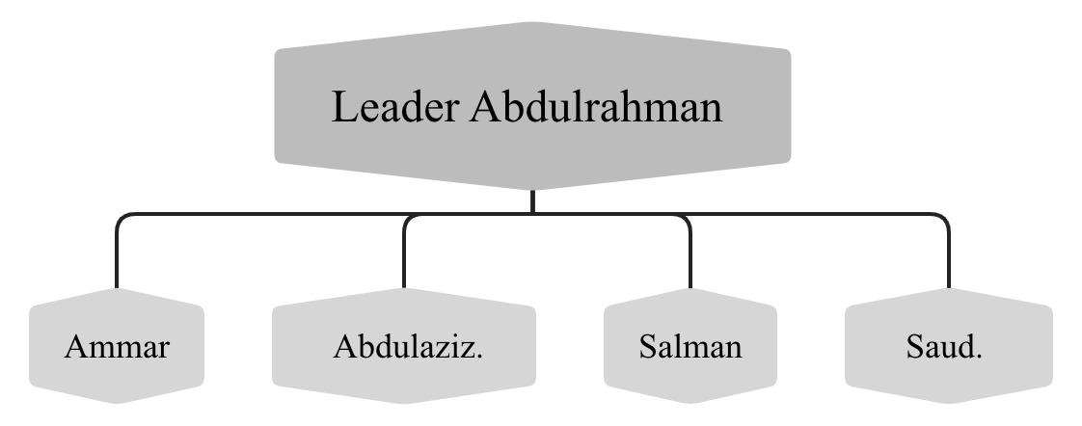

Team Members

Figure 1 Project Organizational Chart

#### The Project Manager

The Project Manager of our project, **FlexiDesk**, is Abdulrahman Kateb. He is in charge of planning, overseeing development, dividing tasks, and making sure everything is executed properly and on time. His role is important for the project’s success.

##### Scope of Authority.

Abdulrahman has the authority to make important decisions for the project. He allocates resources, manages the project team, sets project priorities, establishes timelines, and oversees how the budget is used to complete the project successfully.

##### Scope of Responsibility.

Abdulrahman is responsible for defining what the project should achieve and making sure everything stays within budget. He also manages risks, keeps team members updated on the progress, and ensures good communication among the team members. He checks that all deliverables meet the required standards.

##### Internal Responsibilities.

Our team includes developers who build and maintain the platform, designers who create user-friendly interfaces, and testers who find and report problems.

##### External Responsibilities.

Abdulrahman helps project managers use the platform effectively and makes sure users have good experience.

### Project Roles and Responsibilities

In our project, Abdulrahman is the Project Manager, Designer, and Tester. He oversees everything, makes important decisions, and ensures the project’s success. Ammar and Saud are Developers and Designers to build and maintain the platform. Abdulaziz is a Full Stack Developer who will work on building the platform. Salman is UI/UX Designer to design user-friendly and attractive interfaces, and a Tester.

## Management Process

**FlexiDesk's** management process is meant to make sure that all the project's phases work together smoothly, that resources are used correctly, and that any risks are dealt with before they happen. From the beginning to the end of the project, this section lays out the main steps that will be taken. It covers the steps involved in project startup, work planning, project controls, risk management, and the project closeout procedures. All these areas will be handled by the project team constantly keeping an eye on them and working together to make sure that **FlexiDesk** is delivered on time, within budget, and up to the quality standards that were set.

### Start-up

This section details the initial planning and setup for the **FlexiDesk** project. It includes cost and schedule estimations, staffing plans, resource acquisition, and training for the project team. These steps are crucial for the successful initiation and execution of the **FlexiDesk** platform.

#### Estimation

Based on research conducted through online sources, including Google, the estimated cost for building and launching the **FlexiDesk** platform totals 310 SAR. This estimate includes expenses for purchasing a domain name and web hosting services. Table 5 outlines the estimated time and costs for the various phases of the project. Our confidence in the schedule is high, while we maintain a medium level of confidence in the cost estimation.

|  |  |  |  |
| --- | --- | --- | --- |
| **#** | **Clause** | **Estimated Time** | **Estimated Cost** |
| 1 | Proposal Discussion | 2 Weeks | - |
| 2 | Literature Review | 2 Weeks | - |
| 3 | Introduction | 2 Weeks | - |
| 4 | Software Project Management Plan (SPMP) | 2 Weeks | - |
| 5 | Midterm Report | 1 Week | - |
| 6 | Software Requirements Specification (SRS) | 2 Weeks | - |
| 7 | Software Design Specification (SDS) | 4 Weeks | - |
| 8 | Project Proposal Final Report | 2 Weeks | - |
| 9 | Project Proposal Final Presentation | 1 Week | - |
| 10 | Initial Design UI/UX | 1 Week | - |
| 11 | Final Design UI/UX | 3 Weeks | - |
| 12 | Developing Front End | 9 Weeks | - |
| 13 | Developing Back End | 9 Weeks | - |
| 14 | Building Database | 1 Week | - |
| 15 | Purchasing Domain Name | 1 Day | 60 SAR/Year |
| 16 | Configuring Website on Hosting Service | 2 Weeks | 250 SAR/Year |
| 17 | Preparing Test Plan | 2 Days | - |
| 18 | Testing Phase I | 1 Week | - |
| 19 | Testing and Documenting Final Phase | 3 Weeks | - |
| 20 | Creating User Manual | 1 Week | - |
| 21 | Project Implementation Final Report | 2 Weeks | - |
| 22 | Project Implementation Final Presentation | 1 Week | - |
|  | **Total Estimation** | **30 Weeks** | **310 SAR** |

Table 5 Estimation Table

#### Staffing Plan

Table 6 illustrates the teamwork within the FlexiDesk project team, emphasizing how each member played a role by utilizing their distinct strengths to achieve the project's success. The team collaborated seamlessly, with each member assuming roles that aligned with their strengths to manage different facets of the project efficiently.

|  |  |
| --- | --- |
| **Team Member** | **Role** |
| Abdulrahman | Project Manager/Designer/Tester |
| Saud | Developer/Designer |
| Ammar | Developer/Designer |
| Abdulaziz | Full Stack Developer |
| Salman | UI/UX Designer/Tester |

Table 6 summarized staff planning

Table 7 outlines the project phases, the required skills, duration, and the roles of each team member in the different phases of the project:

|  |  |  |  |
| --- | --- | --- | --- |
| **Phase** | **Skills Needed** | **Duration** | **Team Member Roles** |
| Planning & Documenting | Teamwork, Communication, Planning | 12 Weeks | Abdulrahman (Project Manager), Saud (Documenting), Ammar (Contributor), Abdulaziz (Contributor), Salman (Contributor) |
| Requirements | Analytical Thinking, Communication | 2 Weeks | Ammar (Lead), Abdulrahman (Contributor), Saud (Contributor), Abdulaziz (Contributor), Salman (Contributor) |
| Specification | Critical Thinking, Documentation, Problem Solving | 2 Weeks | Ammar (Lead), Abdulrahman (Contributor), Saud (Contributor), Abdulaziz (Contributor), Salman (Contributor) |
| Design Specification | UI/UX Design, Technical Skills, Collaboration | 4 Weeks | Salman and Abdulrahman (Lead Designers),  Saud (Contributor),  Ammar (Contributor), Abdulaziz (Contributor) |
| Implementation | Technical Skills (HTML, CSS, JavaScript, PHP) | 12 Weeks | Abdulaziz(Lead Developer), Ammar (Developer), Saud (Developer),  Salman (Contributor) Abdulrahman (Contributor) |
| Testing | Problem Solving, Attention to Detail, Testing Skills | 4 Weeks | Abdulrahman (Tester), Salman (Tester) |

Table 7 Detailed staff planning

#### Resource Acquisition

The following table 8 outlines the resources required to complete the **FlexiDesk** project, categorized as software or services:

|  |  |  |  |
| --- | --- | --- | --- |
| **Resource** | **Type** | **Description** | **Star/End date of using** |
| **XAMPP** | Software | Open-source cross-platform web server for local testing [11]. | 2025/01/17 to 2025/05/10 |
| **Microsoft Office** | Software | Word, Excel, PowerPoint through university accounts [12]. | 2024/08/28 to 2025/03/17 |
| **Jira** | Software | Project management software for tracking tasks [8]. | 2024/08/28 to 2025/05/10 |
| **WhatsApp** | Software | WhatsApp is an instant messaging for communicating through text [13]. | 2024/08/28 to 2025/05/10 |
| **Discord** | Software | Communication platform for team meetings and discussions [14]. | 2024/08/28 to 2025/05/10 |
| **Lucidchart** | Software | Web-based diagramming tool for visualizing workflows and designs [15]. | 2024/08/28 to 2025/02/28 |
| **Team Gantt** | Software | Web-based scheduling tool for managing timelines and tasks [16]. | 2024/08/28 to 2025/05/10 |
| **Xmind** | Software | Xmind is a mind mapping and brainstorming tool [17]. | 2024/08/28 to 2025/02/28 |
| **PlantText** | Software | PlantText is an online tool, primarily used to create UML diagrams[19]. | 2024/12/01 to 2024/12/05 |
| **Visual studio** | Software | Visual Studio is an integrated development environment developed used for our development [18]. | 2025/01/17 to 2025/05/10 |
| **Server Configuration** | Service | Third-party service for hosting the website [10]. | 2025/01/17 to 2025/05/10 |

Table 8 Resource Acquisition Table

#### Staff Training

The **FlexiDesk** team will engage in self-training to ensure they have the necessary skills for the project. The training will focus on web development technologies like HTML, CSS, JavaScript, and PHP. Training resources include online platforms such as Udemy, YouTube, and university lab sessions for hands-on learning. The following table 9 outlines the training schedule for each skill and the staff involved:

|  |  |  |
| --- | --- | --- |
| **Resource** | **Duration** | **Staff Involved** |
| HTML | 2 Weeks | Salman |
| CSS | 2 Weeks | Saud |
| PHP | 3 Weeks | Ammar, Saud, Abdulrahman, Salman, Abdulaziz |
| JavaScript | 3 Weeks | Ammar, Saud, Abdulrahman, Salman, Abdulaziz |

Table 9 Staff Training Table

Members will develop both technical and managerial skills to ensure the successful completion of the **FlexiDesk** project.

### Work Planning

This section will provide the detailed work activities, schedule, resources, and budget of **FlexiDesk**, From the early stage of proposal discussion to the implementation and closure.

#### Work Activities

1. Project Proposal

1.1. Initiation

1.1.1. Proposal Discussion

1.1.2. Literature Review

1.2. Planning

1.2.1. Introduction Chapter

1.2.2. Software Project Management Plan (SPMP) Chapter.

1.2.3. Software Requirement Specification (SRS) Chapter.

1.2.4 Midterm Report

1.2.5 Software Design Specification (SDS) Chapter.

1.2.6 Project Proposal Final Report.

1.2.7. Project Proposal Final Presentation

2. Project Implementation

2.1. Executing

2.1.1. Initial Design UI/UX

2.1.2. Final Design UI/UX

2.1.3. Front-end Development.

2.1.4. Back-end Development.

2.1.5. Database Building.

2.1.6. Server Configuration.

2.2. Monitoring and Control

2.2.1. Quality Assurance Testing.

2.2.2. Formal Reviews.

2.3. Closure

2.3.1. Project Implementation Final Report.

2.3.2. Project Implementation Final Presentation.

#### Schedule Allocation

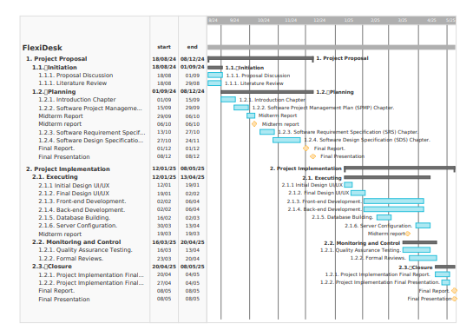Figure 2 is the Gantt chart for our schedule: for better picture click [view](https://udksa-my.sharepoint.com/:b:/g/personal/2210002120_iau_edu_sa/EcVyfmzQu2lAvL_TQJswkfMBWMmmr33pBJ5OlLs9BhZXqg?e=D56bml).

Figure 2 Schedule Gantt Chart

#### Resource Allocation

Table 10 here will show the resources needed for each activity:

|  |  |  |
| --- | --- | --- |
| **Activities** | **Human Resource** | **Other Resources** |
| 1.1.1. Introduction Chapter | All Members | Computer, Microsoft Office, WhatsApp, Discord. |
| 1.1.2. Literature Review | All Members | Computer, Microsoft Office, WhatsApp, Discord. |
| 1.2.1. Introduction Chapter | All Members | Computer, Microsoft Office, WhatsApp, Discord. |
| 1.2.2. Software Project Management Plan (SPMP) Chapter. | All Members | Computer, Microsoft Office, Team Gantt, Lucidchart, Xmind**,** WhatsApp, Discord. |
| 1.2.3. Software Requirement Specification (SRS) Chapter. | All Members | Computer, Microsoft Office, Team Gantt, WhatsApp, Discord. |
| 1.2.4 Midterm Report | All Members | Computer, Microsoft Office, WhatsApp, Discord. |
| 1.2.5. Software Design Specification (SDS) Chapter. | All Members | Computer, Microsoft Office, Lucidchart, WhatsApp, Discord. |
| 1.2.6. Project Proposal Final Report. | All Members | Computer, Microsoft Office, WhatsApp, Discord. |
| 1.2.7. Project Proposal Final Presentation | All Members | Computer, Microsoft Office, WhatsApp, Discord. |
| 2.1.1. Initial Design UI/UX | All Members | Computer, Microsoft Office, Figma, WhatsApp, Discord. |
| 2.1.2. Final Design UI/UX | All Members | Computer, Microsoft Office, Figma, WhatsApp, Discord. |
| 2.1.3. Front-end Development. | All Members | Computer, Microsoft Office, Visual Studio Code, Xampp, WhatsApp, Discord. |
| 2.1.4. Back-end Development. | All Members | Computer, Microsoft Office, Visual Studio Code, Xampp, WhatsApp, Discord. |
| 2.1.5. Database Building. | All Members | Computer, Microsoft Office, Server Configuration, XAMPP, WhatsApp, Discord. |
| 2.1.6. Server Configuration. | All Members | Computer, Microsoft Office, Server Configuration, XAMPP, WhatsApp, Discord. |
| 2.2.1. Quality Assurance Testing. | All Members | Computer, Microsoft Office, WhatsApp, Jira, Discord. |
| 2.2.2. Formal Reviews. | All Members | Computer, Microsoft Office, WhatsApp, Jira, Discord. |
| 2.3.1. Project Implementation Final Report. | All Members | Computer, Microsoft Office, WhatsApp, Discord. |
| 2.3.2. Project Implementation Final Presentation. | All Members | Computer, Microsoft Office, WhatsApp, Discord. |

Table 10 Resource Allocation Table

#### Budget Allocation

Table 11 will show the Cost of each activity:

|  |  |
| --- | --- |
| **Activities** | **Cost** |
| 1.1.1. Introduction Chapter | - |
| 1.1.2. Literature Review | - |
| 1.2.1. Introduction Chapter | **-** |
| 1.2.2. Software Project Management Plan (SPMP) Chapter. | - |
| 1.2.3. Software Requirement Specification (SRS) Chapter. | - |
| 1.2.4 Midterm Report | - |
| 1.2.5. Software Design Specification (SDS) Chapter. | - |
| 1.2.6. Project Proposal Final Report. | - |
| 1.2.7. Project Proposal Final Presentation | - |
| 2.1.1. Initial Design UI/UX | - |
| 2.1.2. Final Design UI/UX | - |
| 2.1.3. Front-end Development. | - |
| 2.1.4. Back-end Development. | - |
| 2.1.5. Database Building. | - |
| 2.1.6. Server Configuration. | 310 SAR/year |
| 2.2.1. Quality Assurance Testing. | - |
| 2.2.2. Formal Reviews. | - |
| 2.3.1. Project Implementation Final Report. | - |
| 2.3.2. Project Implementation Final Presentation. | - |

Table 11 Budget Allocation Table

### Project Controls

#### Requirements Control

Before we started planning activities, we wrote literature reviews to get to know the competitors and the features that we need to have in **FlexiDesk**, that will make it unique and give us a competitive advantage. And in the third chapter (SRS) the functional and non-functional requirements and if there is change in the requirements it, we will meet the project supervisor to discuss whether to add it or not.

#### Schedule Control

We set our schedule on Two reports that we must submit on time, and it will be Reviewed by the evaluators committee. The first report is the midterm report on 06/10/2024, the second report is the final report on 03/11/2024. And we have weekly meetings to share the status of the tasks and measure our performance.

#### Budget Control

Most of the activities that we do are free. There are some activities like domain name and web hosting services. These services have set fees, and they will not be changing anytime soon.

#### Quality Control

We will apply many tests, for example integration testing, user acceptance testing, and many more. To ensure high quality. In addition, utilizing Jira tool for controlling the processes and defects, this will help to find and solve the defects as early as possible, preventing us from unknown defects that may double the cost of solving it

#### Project Reporting and Communication

##### Electronic Media.

* Discord
* WhatsApp

##### Meetings.

Two or three weekly meetings with the team members if needed. And one weekly meeting with the project supervisor.

##### Information Repository.

* OneDrive
* Microsoft Office Online

##### Reviews.

After each chapter we review it with the project supervisor, so we get the feedback and refine and enhance the chapter. And there are 2 Reviews from the evaluators committee.

##### Status Reporting.

We have 12 status reports, 6 on Project Proposal and 6 on Project Implementation, between them approximately 2-4 weeks.

### Risk Management

The following table 12 identifies the potential risks associated with the **FlexiDesk** project, categorizes their type, evaluates their probability and impact, and defines the response actions to mitigate these risks.

|  |  |  |  |  |
| --- | --- | --- | --- | --- |
| **Potential Risk** | **Type** | **Probability** | **Impact** | **Response Action** |
| **Data Breach** | Security | Medium | High | Implement strong encryption, regular security audits, and access control measures. |
| **Server Outages** | Technical | High | High | Implement a backup server plan, use reliable hosting services, and maintain monitoring tools. |
| **Schedule Delays** | Scheduling | Medium | High | Break down tasks into manageable parts, monitor progress, and adjust timelines early. |
| **Skill Gaps in Team** | Personnel | Medium | Low | Provide training, conduct skills assessments, and consider hiring additional resources. |

Table 12 Risk Management Table

### Project Closeout

At the end of the **FlexiDesk** project, we will have a meeting with all team members to talk about how things went and the important lessons we learned. This will help find ways to do better in future projects. After the meeting, all project materials, like reports, and source code, will be safely stored on the IAU Blackboard. This makes sure that all resources are simple to find for us in the future.

## Technical Process

### Process Model

For the **FlexiDesk project**, we are using the **Waterfall Model**, which is a step-by-step, sequential approach to developing software. This model suits our project because it allows us to follow a clear structure and ensures that every phase is well-documented and completed before moving to the next one.

1. **Project Proposal and Requirements**  
    This is the current phase we are in. We are documenting the project proposal, identifying the features FlexiDesk will include, and outlining its functionality based on what we envision the system should do. This includes features like AI suggestions, collaboration tools, and project dashboards.
2. **System Design**  
    In this phase, we will design the architecture of FlexiDesk. This includes creating mockups and wireframes for the user interfaces (e.g., landing page, task management, and notification features) and planning how the platform will function, including how data will flow between components.
3. **Implementation**  
    After the design is finalized, we will start developing the platform by writing code. This will include building the interface, integrating features like AI-driven suggestions and dashboards, and creating a database to store project information.
4. **Testing and Validation**  
    Once the implementation is complete, we will test the platform. We will simulate real-world usage to identify and fix bugs, ensure the system is user-friendly, and validate that the features function as planned.
5. **Final Delivery**  
    In this phase, the completed FlexiDesk platform will be finalized and submitted as part of the graduation project. This includes the final documentation, mockups, and demonstration of the system's features to evaluators.

Figure 3 show the phases for FlexiDesk development using waterfall model

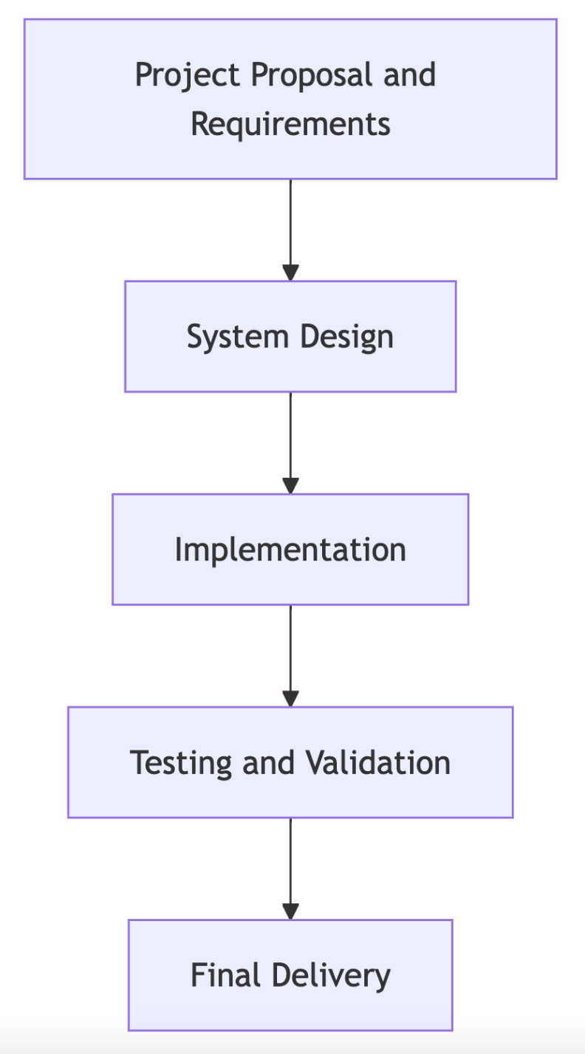

Figure 3 Waterfall Model Phases for FlexiDesk Development

### Applicability of Technologies in Business Environments

FlexiDesk uses modern technologies to help businesses work better and faster. Here’s how:

1. **AI Assistance**

FlexiDesk has an AI assistant, "FlexiBot," that helps project managers by giving smart suggestions. It can recommend changes like adjusting deadlines or priorities to keep projects on track.

1. **Cloud-Based Access**

The platform works online, so project managers and team members can use it from anywhere. This makes it easy to stay connected and share updates in real-time.

1. **Task Management Tools**

Features like Gantt charts and notifications help teams see what needs to be done and stay organized. These tools save time and make work easier for everyone.

1. **Safe and Scalable**

FlexiDesk is secure and can handle more users as the business grows. It works well for small teams or big companies.

1. **Easy to Use**

The platform is designed to be simple and user-friendly, so teams can start using it right away without much training. Features like the discussion area and whiteboard make teamwork easier.

### Methods, Tools and Techniques

* + **Hardware**: Computers and laptops.
  + **Software**:
* **MS Office** for reports and documentation.
* **MySQL** for managing the database.
* **PHP**, **CSS**, and **JavaScript** for coding the website.
* **Lucidchart** & **Xmind** for drawing diagrams and sketches.

### Project Infrastructure

We are using Windows and Mac computers for coding. We use cloud services to host our project online, and MySQL to manage all the user data. PHP Laravel is used for both the front-end, which is what users see, and the back-end, which handles how the system works in the background.

### Product Acceptance

To make sure our product is accepted, we will deliver it in different chapters or milestones. Our supervisor will review each chapter to make sure the work is done correctly. First, our team will look and check the product, and then the supervisor will evaluate it. The product must meet the goals and requirements we set at the beginning. We will use user acceptance testing and performance testing to check how well the product works before we finalize it.

## Supporting Processes

### Configuration Management

The Configuration Management Plan for **FlexiDesk** involves identifying, controlling, and tracking changes to the project’s key components, including Progress Tracking, Built-in Communication Platform, View Options, AI Advisor, Real-Time Collaboration, and Report Generator. Configuration items (CIs) such as the source code, database schema, project templates, and AI Advisor will be tracked and managed throughout the project.

All changes to the platform must be approved by the Change Control Board (CCB), represented by the evaluators committee, and these changes will be logged, reviewed, and tested before implementation to ensure accuracy and stability. Jira will be used for tracking all changes and maintaining status.

Before changes are deployed, there will be a formal evaluation process to determine functionality and stability. Configuration management will be optimized by automated tools, such as Jira for issue tracking and change management, which will guarantee effective handling of change tracking.

### Independent Verification and Validation

For **verification,** we will conduct reviews at key project milestones to evaluate progress in line with the project’s goals. These reviews will assess if each phase of the development process is completed as expected. Also, peer reviews to evaluate code and design documents, identifying any issues early on to ensure that the platform meets the required standards.

For **validation,** we will conduct testing activities, including functional and performance testing. This will ensure that **FlexiDesk** meets the needs of project managers and team members using our platform. Additionally, validation will involve analyzing the platform to confirm that it fulfills all specified requirements. We will inspect the code to know any potential issues, ensuring that the final product is reliable.

### Documentation

* + **Introduction Chapter**: Provides an overview of the **FlexiDesk** project, its objectives, and overall structure.
  + **SPMP Document**: Describes the project management plan.
  + **SRS Document**: Outlines the system’s requirements and scope.
  + **SDS Document**: Provides the architectural and technical details of the system.
  + **Test Plan**: Defines the strategy and approach for testing **FlexiDesk**.
  + **Testing Reports**: Document the results of software testing activities, including any identified issues and their resolutions.
  + **User Manual**: Provides instructions for project managers and team members on how to use **FlexiDesk** and including guidelines.

|  |  |  |  |
| --- | --- | --- | --- |
| Document Type | Format Standard | Estimated Page Count | Peer Review Type |
| Introduction Chapter | IEEE Standard | 14 | Content Review |
| SPMP Document | IEEE Standard | 20-25 Pages | Structure & Content Review |
| SRS Document | IEEE Standard | 20-30 Pages | Requirement Verification |
| SDS Document | IEEE Standard | 20-30 Pages | Design Consistency Review |
| Test Plan | IEEE Standard | 10-15 Pages | Testing Strategy Review |
| Testing Reports | IEEE Standard | 10-15 Pages | Results & Accuracy Check |
| User Manual | IEEE Standard | 10-12 Pages | Usability Review |

Table 13 FlexiDesk Documentation Table

### Quality Assurance

* **FlexiDesk** will go through a comprehensive quality assurance.
* **Integration Testing**: Testing will focus on the interaction between various components.
* **System Testing**: The user workflows, including project creation, task assignments, and collaboration features.
* **User Acceptance Testing (UAT)**: **FlexiDesk** will be used in real-world project scenarios to verify the platform’s usability and effectiveness.
* **Performance Testing**: Load, stress, and scalability testing to ensure that the platform performs well with the expected number of users.
* **Release Audits**: All documentation, code, and testing results will be audited against the project’s requirements.
* **Security Testing**: The assessments will be based on common vulnerabilities such as OWASP's Top 10.

Any defects discovered during these activities will be tracked and managed.

### Reviews and Audits

The Reviews and Audits Plan for **FlexiDesk** outlines the processes for regularly reviewing and auditing the project to ensure quality and compliance. Different types of reviews will be conducted throughout the project, including **Design Review** to ensure that the platform meets all specified requirements, and **Code Review**, where peers will review code to ensure consistency with the design specifications. **Process Audits** will be performed to verify that the project complies with management standards, while **Post-Implementation Review** will evaluate the entire project once completed. Also, reviews will be conducted at each milestone.

### Problem Resolution

The Problem Resolutionfor **FlexiDesk** is that any issues or defects encountered during the project are efficiently identified, tracked, and resolved. We will use **Jira** as our issue tracking system, where problems will be logged with relevant details and assigned to a responsible team member. allowing the team to improve processes and minimize disruptions in future phases of the project. A **root cause analysis** for each reported issue to identify the cause and how to prevent it. Once a solution is proposed, it will be implemented and tested to ensure the problem is fully resolved. If a problem is still not solved, then the required step is to get help from our supervisor by the team leader for a proper evaluation of the problem. A suitable plan for problem resolution will be implemented to address the issue.

### Contractor Management

For **FlexiDesk**, all work will be performed internally.

### Process Improvement

The Process Improvement Plan for refining and optimizing **FlexiDesk** processes to maintain efficiency and quality. Regular assessments to identify areas for improvement, while root cause analysis will address recurring issues to prevent it. Improvement plans will be developed and implemented step by step to avoid disruption.

#### Systems/Software Process Improvement Lead

The Process Improvement Lead is responsible for overseeing process improvements in the **FlexiDesk** project, ensuring that improvements align with project goals and are implemented correctly.

#### Systems Engineering Process Group

The Systems Engineering Process Group (SEPG) supports the Process Improvement Lead by identifying and evaluating the areas for improvement and ensuring that technical and system engineering aspects align with overall project improvements.

# Requirements Specification

## Chapter Summary

This chapter explains the Software Requirements Specification (SRS) for FlexiDesk. It describes what the system will do and how it will work. The chapter starts with an overview of the system, including its main features, the environment it will run in, and who will use it. It also explains how FlexiDesk connects with other systems, like user interfaces and communication tools. A simple use case diagram shows how users will interact with FlexiDesk. Each feature of the system is listed with details on how it works and how important it is. The chapter also covers other important requirements, like how well the system should perform, how safe it is, and how easy it is to use. These requirements will help make sure that FlexiDesk is reliable and works smoothly for users.

## Overall Description

### Product Perspective

FlexiDesk is a standalone project management software. It helps project managers and team members to communicate, manage tasks, and track progress all in one place. The system does not rely on any other software to function but can be integrated with external tools like calendars and messaging apps if needed.

### Product Functions

* **User Registration and Authentication**: Allows users to create accounts, log in securely, and manage access to the system.
* **Task and Project Management**: Enables project managers to create projects, set tasks, assign them to team members, and set deadlines.
* **User Profile Management**: Lets users update and manage their profiles, including contact information and task preferences.
* **Progress Tracking and Dashboards**: Provides tools to track the progress of tasks and projects, showing clear status updates on a dashboard.
* **Real-Time Collaboration**: Allows team members to chat, share files, and collaborate using a shared whiteboard in real-time.
* **Report generating:** Generates detailed reports on project progress, completed tasks, and upcoming deadlines.
* **AI Advisor**: Offers suggestions on project improvements, such as task prioritization and making deadlines or even suggesting tasks, to help manage projects efficiently.
* **Notifications and Alerts**: Sends alerts to users about important updates, deadlines, tasks and messages.

### User Classes and Characteristics

The main users of FlexiDesk are:

* **Project Managers**: They will use the system to create projects, assign tasks, and oversee progress.
* **Team Members**: They will use FlexiDesk to check tasks, complete assignments, and communicate with other team members.

### Operating Environment

FlexiDesk is a web-based platform that can be accessed through web browsers such as Google Chrome, Firefox, Safari, and others. It is designed to work on various devices, including desktops, laptops, and mobile devices. The system is independent of specific operating systems, allowing users to access it on Windows, macOS, Linux, Android, and iOS. The server-side components and the application are hosted on a web server, with specific configurations depending on the hosting choices. While the platform is self-contained for managing projects, it may interact with external systems, such as database management systems, for data storage. This design ensures that FlexiDesk is accessible and easy to use for a wide range of users, regardless of their device or operating system.

### Design and Implementation Constraints

FlexiDesk must follow certain rules during development. It needs to be user-friendly, secure, and compatible with different devices and web browsers. The software must also handle multiple users at the same time without slowing down.

### User Documentation

FlexiDesk will have a user guide available to help users understand how to use the platform. This will include a step-by-step user guide manual, which can be accessed directly through the software interface. The documentation will be clear and easy to read, ensuring users can find the information they need when they need it, improving their overall experience with the platform.

### Assumptions

It is assumed that users will have basic computer skills and internet access. We also assume that users will follow the instructions provided in the user guides. project, unless they are already documented elsewhere (for example, in the vision and scope document or the project plan)

### Dependencies

FlexiDesk does not depend on any specific software to work. However, it will integrate smoothly with common tools like email and calendar apps to enhance user experience.

## External Interface Requirements

### User Interfaces

The FlexiDesk platform has a general interface for both project managers and team members, along with specialized interfaces tailored to each role's needs, offering distinct features for efficient and easy use. The details of each type are as follows:

#### General interfaces

1. Landing page
2. Homepage

* Team Communication
* Project page (Gantt, Table or Calendar view)
* Progress bar
* Contact us

1. Download reports
2. Reset Password

* New Password Setup Page

#### Project manager interfaces

1. Login Page
2. Signup Page
3. Homepage
4. Project Creation Page
5. Update Profile Page

#### Team member interfaces

1. Login Page
2. Signup Page
3. homepage
4. Task management
5. Update Profile Page

### Hardware Interfaces

- Compatible with desktops, laptops, and mobile devices.

- Minimum resolution: 1024x768.

- Minimum memory: 2GB of RAM.

### Software Interfaces

- Backend: Node.js 16 or later.

- Database: MySQL 8.0 or later.

- Frontend: React.js framework.

- Browser compatibility: Chrome, Firefox, Safari, and Edge.

### Communications Interfaces

- HTTP and HTTPS protocols for communication.

- Email notifications use SMTP protocol.

- Real-time updates handled via WebSocket connections.

## Use Case Diagram

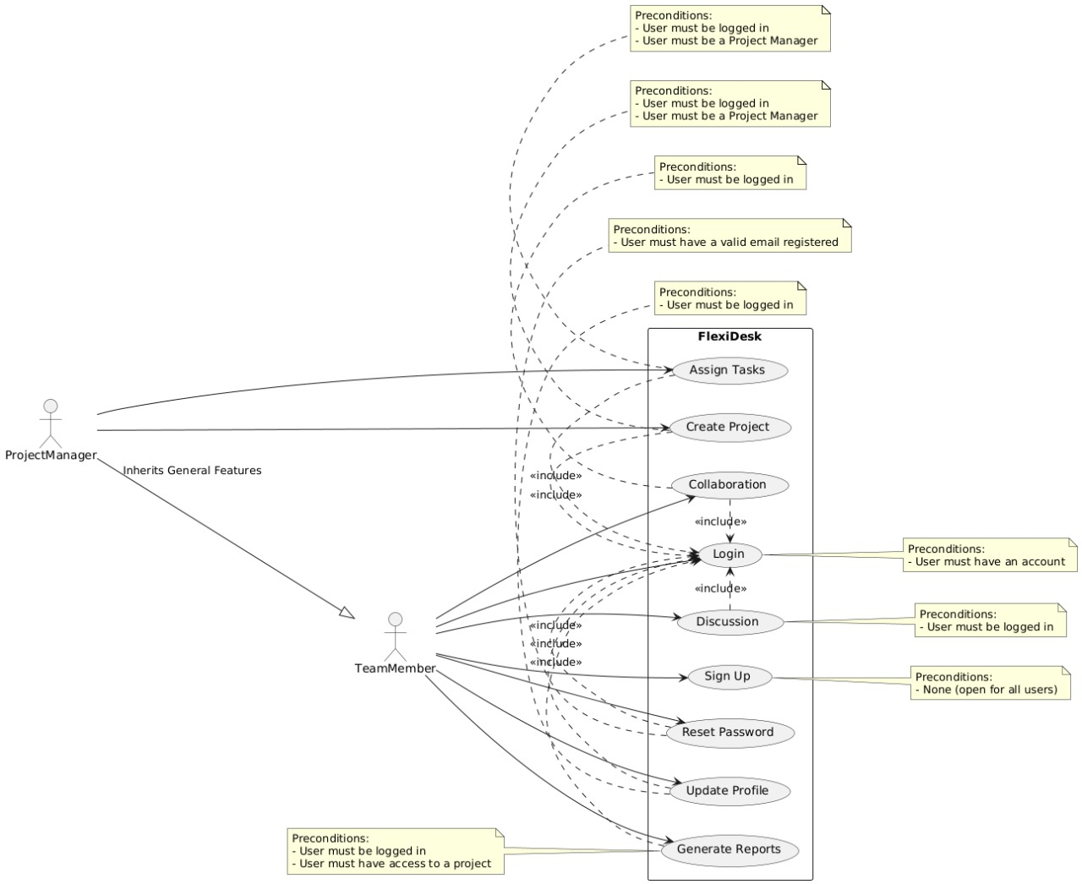

Figure 4 FlexiDesk Use Case Diagram

## System Features

### Sign Up

|  |  |
| --- | --- |
| **ID** | **REQ-1** |
| **Actor** | Project Manager, Team Member |
| **Description** | Users can register an account by providing their details. |
| **Preconditions** | Sign-up page is displayed. |
| **Postconditions** | User account is created and stored in the database. |
| **Normal Flow** | 1. User opens the sign-up page.  2. Fills in details.  3. Verifies email.  4. Completes registration. |
| **Alternative Flow** | If the email is already in use, an error message is displayed. |
| **Priority** | High |

Table 14 System Features: Sign Up

### Login

|  |  |
| --- | --- |
| **ID** | **REQ-2** |
| **Actor** | Project Manager, Team Member |
| **Description** | Users can log in to access their accounts. |
| **Preconditions** | Login page is displayed. |
| **Postconditions** | Users gain access to the platform based on their roles. |
| **Normal Flow** | 1. User enters email/password.  2. Credentials are validated.  3. Access is granted. |
| **Alternative Flow** | If credentials are incorrect, an error message is displayed. |
| **Priority** | High |

Table 15 System Features: Login

### Reset Password

|  |  |
| --- | --- |
| **ID** | **REQ-3** |
| **Actor** | Project Manager, Team Member |
| **Description** | Allows users to reset their password if they forget it. |
| **Preconditions** | The user has a registered email address. |
| **Postconditions** | The user's password is updated securely in the database. |
| **Normal Flow** | 1. User clicks "Forgot Password."  2. Enters their email address.  3. Receives a verification code.  4. Creates a new password. |
| **Alternative Flow** | If the verification code is invalid, an error message is displayed. |
| **Priority** | High |

Table 16 System Features: Reset Password

### Task and Project Management

|  |  |
| --- | --- |
| **ID** | **REQ-4** |
| **Actor** | Project Manager, Team Member |
| **Description** | Enables managers to create and assign tasks and track their progress. |
| **Preconditions** | User must be logged in. |
| **Postconditions** | Task information is stored in the system and displayed on dashboards. |
| **Normal Flow** | 1. Manager creates a task.  2. Assigns the task to a team member.  3. Sets a deadline.  4. Task appears in the assignee's dashboard. |
| **Alternative Flow** | If task creation fails (e.g., missing fields), the system displays an error message. |
| **Priority** | High |

Table 17 System Features: Task and Project Management

### Real-Time Collaboration

|  |  |
| --- | --- |
| **ID** | **REQ-5** |
| **Actor** | Project Manager, Team Member |
| **Description** | Provides real-time chat, file sharing, and a collaborative whiteboard. |
| **Preconditions** | Both users must be logged in. |
| **Postconditions** | Messages and shared files are stored and displayed in real-time. |
| **Normal Flow** | 1. User opens the collaboration tool.  2. Sends a message or file.  3. Other users receive notifications instantly. |
| **Alternative Flow** | If the user is offline, notifications are queued for when they return. |
| **Priority** | High |

Table 18 System Features: Real-Time Collaboration

### Progress Tracking and Dashboards

|  |  |
| --- | --- |
| **ID** | **REQ-6** |
| **Actor** | Project Manager, Team Member |
| **Description** | Visual dashboards displaying real-time task and project progress. |
| **Preconditions** | User must be logged in. |
| **Postconditions** | Progress updates are reflected on the dashboard in real time. |
| **Normal Flow** | 1. User navigates to the dashboard.  2. Updates a task's status.  3. Dashboard reflects the updated progress. |
| **Alternative Flow** | If the user is offline, progress changes are updated when they reconnect. |
| **Priority** | High |

Table 19 System Features: Progress Tracking and Dashboards

### Report generating

|  |  |
| --- | --- |
| **ID** | **REQ-7** |
| **Actor** | Project manager, team member |
| **Description** | Generates task progress and project status reports. |
| **Preconditions** | At least one project must exist in the system. |
| **Postconditions** | A downloadable report is generated in Excel format. |
| **Normal Flow** | 1. user selects "Download Report."  2. Downloads the report. |
| **Alternative Flow** | If no data exists, the system notifies the user that reports cannot be generated. |
| **Priority** | Medium |

Table 20 System Features: Report generating

### System Features: Notifications and Alerts

|  |  |
| --- | --- |
| **3** | **REQ-8** |
| **Actor** | Project Manager, Team Member |
| **Description** | Sends reminders about deadlines, task assignments, and Messages. |
| **Preconditions** | User must be logged in. |
| **Postconditions** | Notifications appear on the notification page and are sent via email. |
| **Normal Flow** | 1. Task deadline approaches.  2. System sends a notification to the assignee.  3. User views the alert. |
| **Alternative Flow** | If email delivery fails, the system retries sending it. |
| **Priority** | High |

Table 21 System Features: Notifications and Alerts

### System Features: User Management

|  |  |
| --- | --- |
| **ID** | **REQ-9** |
| **Actor** | Project Manager, Team Member |
| **Description** | Allows users to update their profiles and manage account settings. |
| **Preconditions** | User must be logged in. |
| **Postconditions** | Profile changes are saved in the database. |
| **Normal Flow** | 1. User navigates to the profile page.  2. Updates their information.  3. Changes are saved and displayed. |
| **Alternative Flow** | If changes fail to save, an error message is displayed. |
| **Priority** | Medium |

Table 22 System Features: User Management

## Other Nonfunctional Requirements

This subsection outlines other non-functional requirements for the **FlexiDesk** platform, including performance, safety, security, software quality attributes, and business rules. These ensure the platform is secure, efficient, and user-friendly, meeting the needs of project managers and team members.

### Performance Requirements

The platform must meet performance standards to ensure smooth user interactions:

* **REQ-1**: The system shall support up to 200 simultaneous users with a response time of less than 2 seconds under normal load conditions.
* **REQ-2**: Real-time updates for task collaboration and dashboards must reflect within 1 second of user input.
* **REQ-3**: The platform shall maintain uptime of 99.9% to ensure accessibility. We chose **99.9% uptime** based on industry standards. Most reliable hosting providers, like AWS and Google Cloud, offer 99.9% uptime in their service level agreements, making it a realistic benchmark. This percentage means the system allows for about 43 minutes of downtime per month, ensuring minimal disruption to users.
* **REQ-4:** The system shall have a maximum **error rate of 2 errors per 100 users per 24 hours** during normal use. This includes actions such as invalid login attempts, incorrect form submissions, or task input errors. **Explanation:** This requirement is critical to ensuring usability and smooth operation. It is based on expected user behavior during testing phases and typical platform usage patterns. By setting this limit, we aim to maintain a balance between system reliability and user satisfaction while minimizing interruptions caused by common mistakes. The platform incorporates clear error messages and user-friendly prompts to assist users in resolving these issues efficiently.

These performance requirements ensure that FlexiDesk delivers a seamless experience, even under high usage scenarios.

### Safety Requirements

The system must prioritize user safety and protect data from unauthorized access:

* **REQ-1**: The system shall implement user access controls to prevent unauthorized access to sensitive information.
* **REQ-2**: Inactive users shall be logged out automatically after 10 minutes of inactivity to prevent data breaches.
* **REQ-3**: User actions that could lead to data loss, such as task deletion, must include a confirmation prompt.
* **REQ-4**: Errors shall be handled gracefully without exposing sensitive technical details to the end user.

These requirements are critical to maintaining trust and protecting user data.

### Security Requirements

To ensure data protection and secure access, the following measures must be implemented:

* **REQ-1**: All user data exchanges will be encrypted.
* **REQ-2**: User passwords shall be hashed.
* **REQ-3**: The system shall require two-factor authentication (2FA) for project managers accessing administrative features.

These security measures safeguard against data breaches and unauthorized access.

### Software Quality Attributes

FlexiDesk must adhere to the following software quality attributes to ensure a superior user experience:

* **User Experience**: Provide a clean and intuitive interface for task and project management.
* **Reliability**: The system must minimize downtime and ensure reliable task updates and notifications.
* **Scalability**: The platform must handle increased loads as teams grow in size or more tasks are created.
* **Usability**: Ensure all users can perform essential actions (e.g., assigning tasks) in less than 3 clicks.

These attributes guarantee that FlexiDesk is robust, user-friendly, and capable of scaling for future needs.

### Business Rules

The following rules govern how users interact with the system:

* **User Roles**:
  + Only project managers can create and assign tasks.
  + Team members can only update or mark tasks as complete.
* **Task Creation and Management**:
  + All tasks must have deadlines and assigned owners.
  + Tasks cannot be deleted without confirmation.
* **Data Management**:
  + User data shall be stored securely in compliance with GDPR regulations.
  + Project data must be backed up daily and retained for 30 days.

These rules ensure proper system functionality, compliance, and clear role definitions.

# Design Specifications

## Chapter Summary

A brief overview of what the chapter covers.

## System Overview

FlexiDesk is a centralized project management platform for both project managers and team members, offering an easy and intuitive user experience. It is designed to optimize productivity, communication, and enhance project oversight.

**System Functionalities**

1. **Common Features for All Users:**
   * **User Registration and Login:** Secure sign-up and login functionalities.
   * **Profile Management:** Update personal details and data.
   * **Real-Time Notifications:** Receive alerts about deadlines, updates, and new tasks.
   * **Task Progress Tracking:** View ongoing and completed tasks in an organized format.
2. **Project Manager-Specific Functionalities:**
   * **Task Creation and Assignment:** Create tasks and assign them to specific team members with deadlines.
   * **Progress Monitoring Tools:** Use Gantt charts, and calendar views to oversee project timelines.
   * **AI Advisor:** Receive recommendations for resource allocation and task prioritization.
   * **Generating reports:** Generate reports summarizing project status and team performance.
3. **Team Member-Specific Functionalities:**
   * **Task Viewing and Updates:** Access assigned tasks and provide status updates.
   * **Interactive Whiteboards:** Collaborate with other team members in real time for brainstorming sessions.

**Access and Integration**

FlexiDesk supports a web-based interface accessible via major browsers and devices. The system can integrate with tools like email clients and calendar applications to enhance user experience.

## Design Considerations

### Assumptions and Dependencies

* **End-User Characteristics:**
  + Users have little knowledge of web applications.
  + Targeted at teams of various sizes, from students to corporate project groups.
* **Dependencies:**
  + Requires an internet connection for real-time updates.
  + Uses MySQL as the backend database and VS for the front-end interface.
* **Assumptions:**
  + Users will actively use notifications and AI recommendations for project management.
  + All users have access to devices with compatible browsers.

### Constraints

* **Performance Constraints:**
  + Should handle up to 200 simultaneous users without latency exceeding 2 seconds.
  + Ensure uptime of 99.9% to maintain reliability.
* **Security Constraints:**
  + All communications must use HTTPS with TLS encryption.
  + User data is stored using secure hashing and encryption methods (e.g., bcrypt for passwords).
* **Usability Constraints:**
  + Designed to be accessible across different devices, including desktops and mobile platforms.
  + The interface must be intuitive, allowing key actions to be completed within 3 clicks.
* **Scalability:**
  + FlexiDesk's database and infrastructure should scale to support increased user activity and larger teams.

### Design Principles

* **User-Centered Design:**
  + Iterative development based on user feedback to enhance usability.
  + Minimized steps for task completion.
* **Responsive Design:**
  + Ensures functionality across different screen sizes and resolutions.
* **Security by Design:**
  + Incorporates robust authentication, access control, and data encryption.
* **Modularity:**
  + Flexible architecture that supports the addition of new features with minimal disruption.
* **Testing Frameworks:**
  + Use automated testing for quality assurance to ensure bug-free performance.

## User Interface Design

This section provides an overview of user’s interfaces, mockup for the proposed  
system, and design rules.

### Overview of User Interface

This subsection provides an overview of user’s interfaces

#### General interfaces

1. Landing page
2. Contact Us page
3. Homepage
4. Reset Password
5. New Password Setup Page

#### Project manager interfaces

1. Login Page
2. Signup Page
3. homepage
4. Project Creation Page
5. Update Profile Page

#### Team member interfaces

1. Login Page
2. Signup Page
3. homepage
4. Update Profile Page

### Interface Design Rules

The interface design for FlexiDesk follows these principles to ensure a smooth and user-friendly experience:

1. **Simplicity**: The design is minimalistic, focusing on essential elements with no unnecessary distractions. This approach helps users easily navigate the platform.
2. **Consistency**: All pages follow a consistent layout and design style, including font sizes, button placements, and color schemes. This consistency ensures that users feel comfortable as they move between different pages.
3. **Accessibility**: The platform is designed to be accessible across various devices, including desktops, laptops, and mobile devices. FlexiDesk supports commonly used web browsers like Chrome, Firefox, and Safari.
4. **User-Centered Design**: Interfaces are designed with the user in mind. Project managers and team members can quickly find the tools they need, with clear labels and intuitive navigation.
5. **White Space Utilization**: Inspired by Apple’s design style, FlexiDesk uses ample white space to give the interface a clean and uncluttered look, reducing cognitive load for users.
6. **Visual Feedback**: Interactive elements like buttons and links provide immediate visual feedback, such as highlighting or animation, to indicate user actions.
7. **Error Handling**: Clear and helpful error messages guide users when something goes wrong, ensuring they can quickly correct any mistakes.
8. **Responsiveness**: The interface adjusts seamlessly to different screen sizes, ensuring a smooth experience whether users access the platform on a computer or a mobile device.

### interfaces mockup

The following sections present the user interfaces

#### General Interfaces

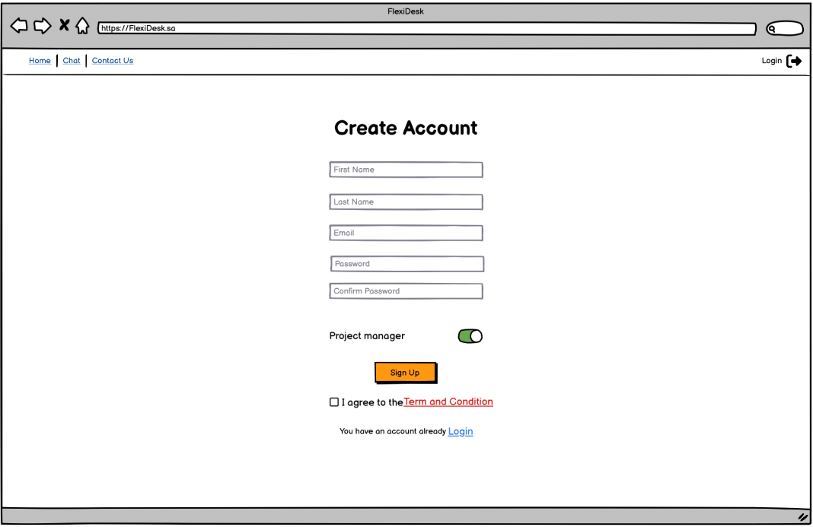

Figure 5 Sign up page

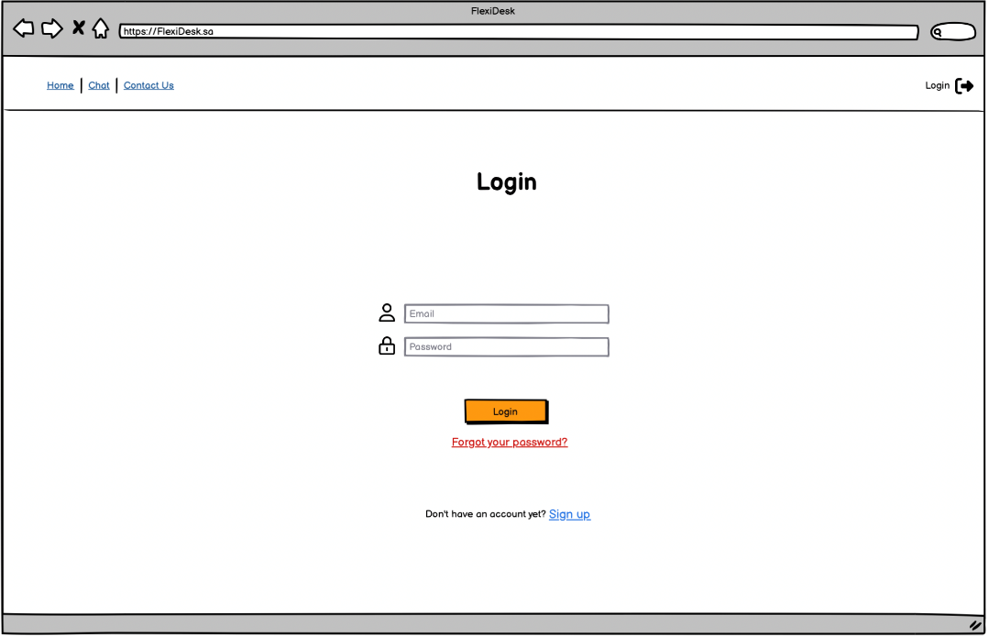

Figure 6 Log in page

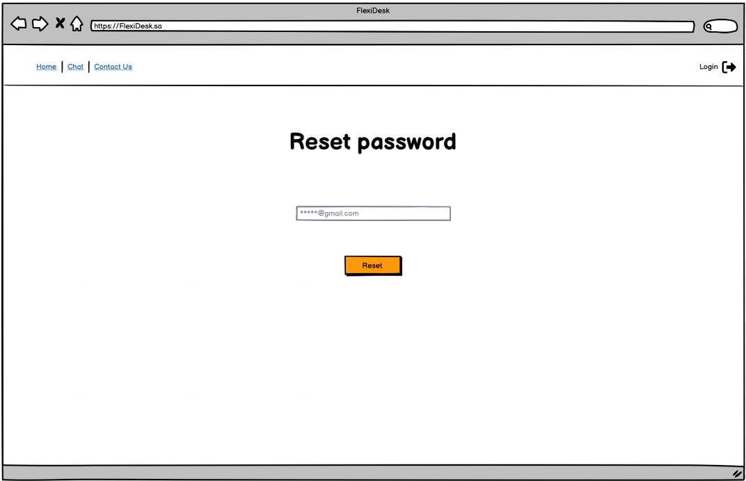

Figure 7 Reset Password Page "Enter Email Step"

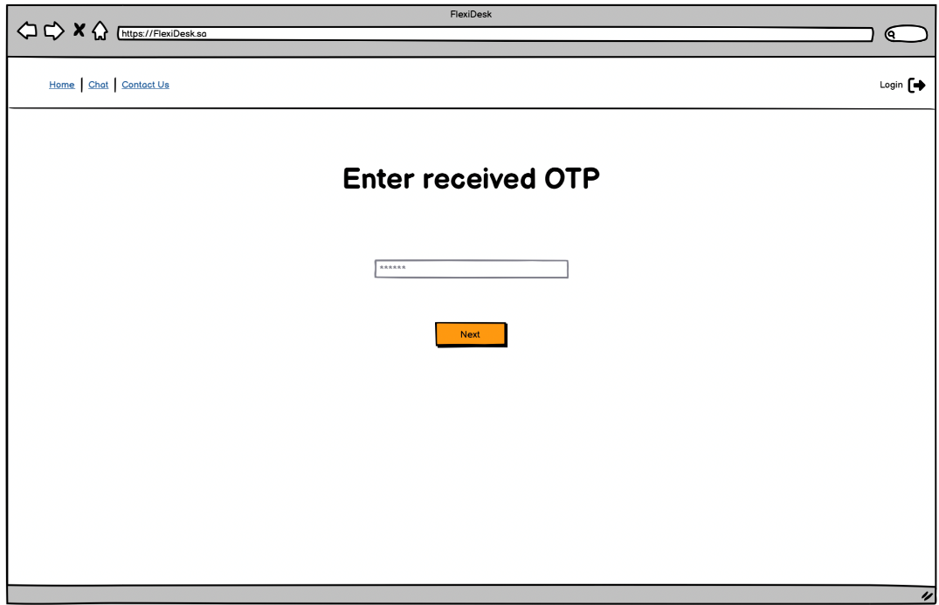

Figure 8 Reset Password Page "Enter OTP Step"

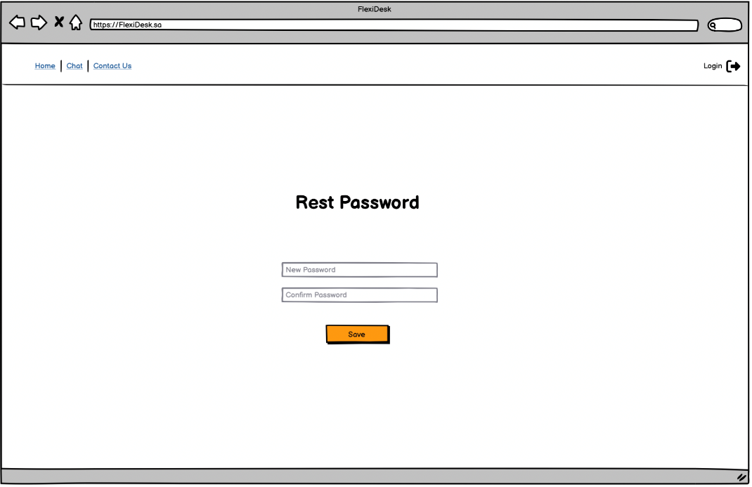

Figure 9 Reset Password Page "Enter New Password Step"

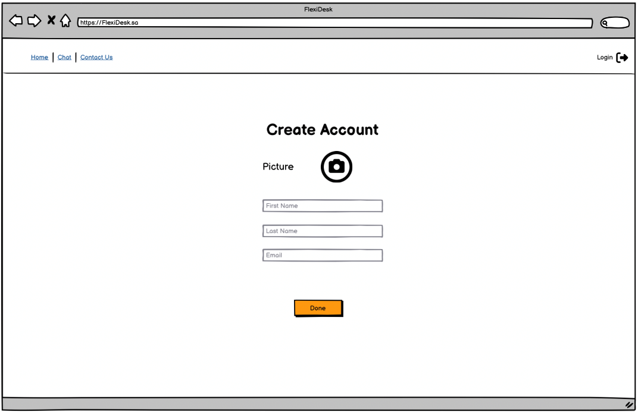

Figure 10 Update Profile Page

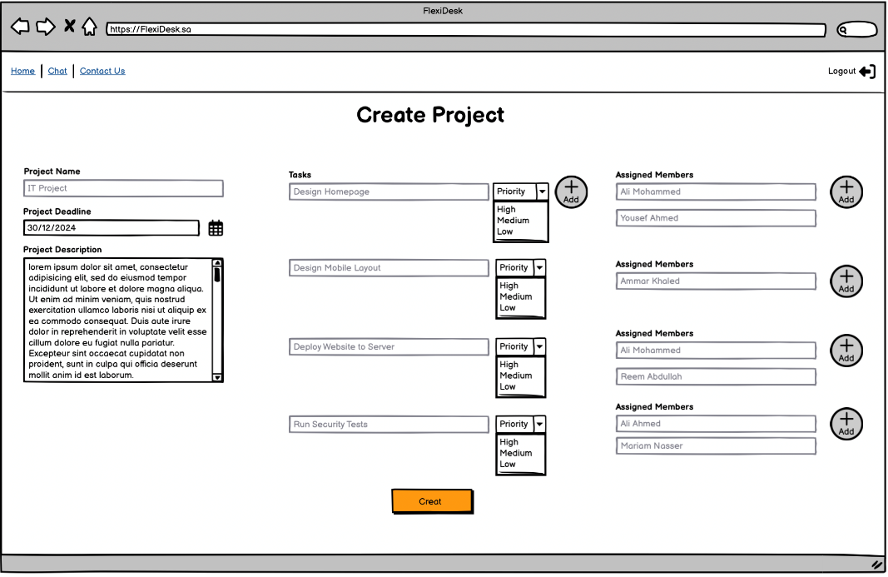

Figure 11 Create Project page

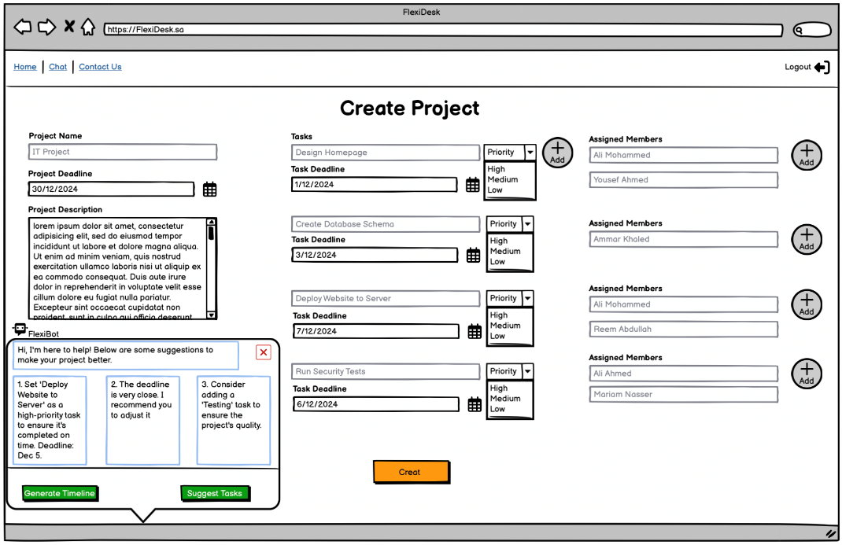

Figure 12 Create Project page with AI pop notification

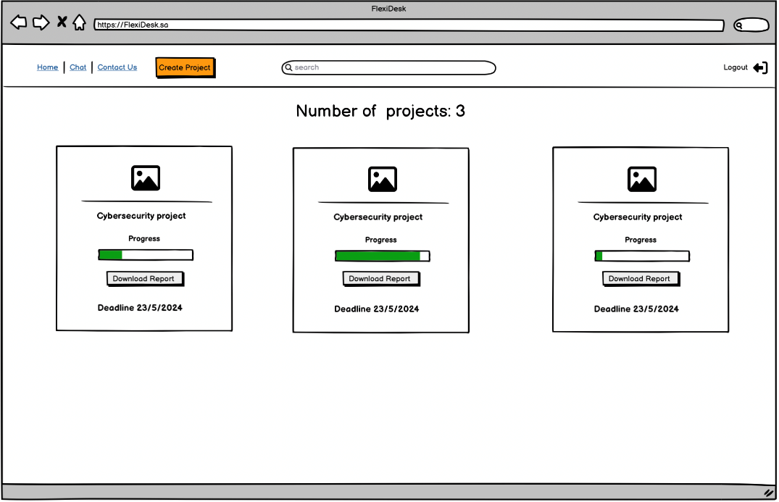

Figure 13 Homepage

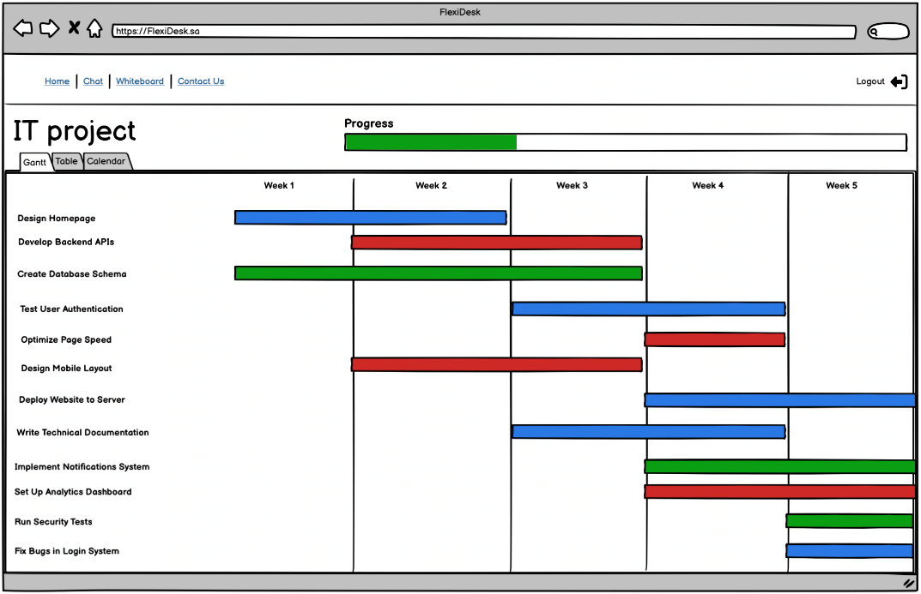

Figure 14 Project page "Gantt"

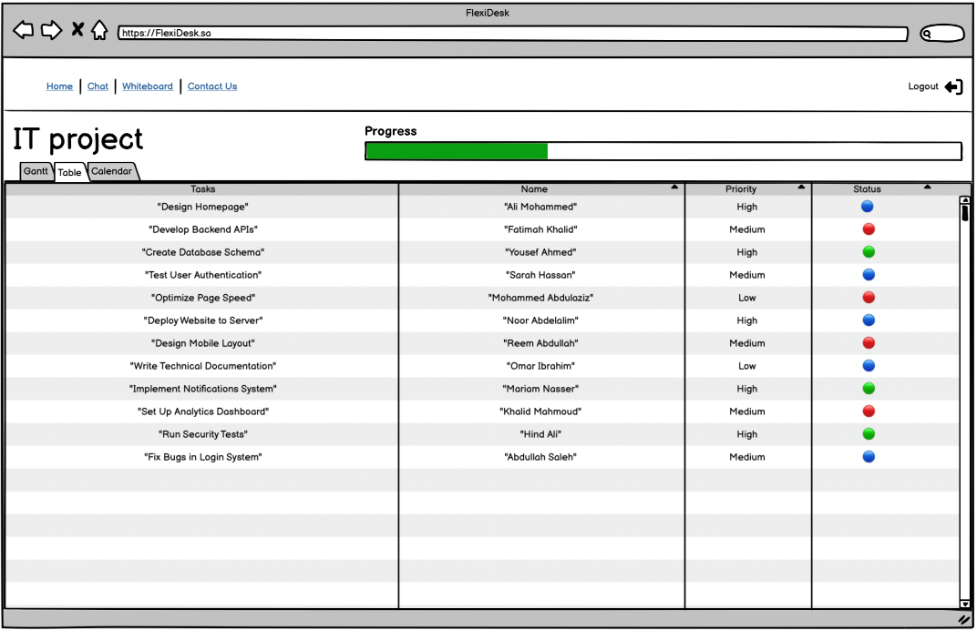

Figure 15 Project page "table"

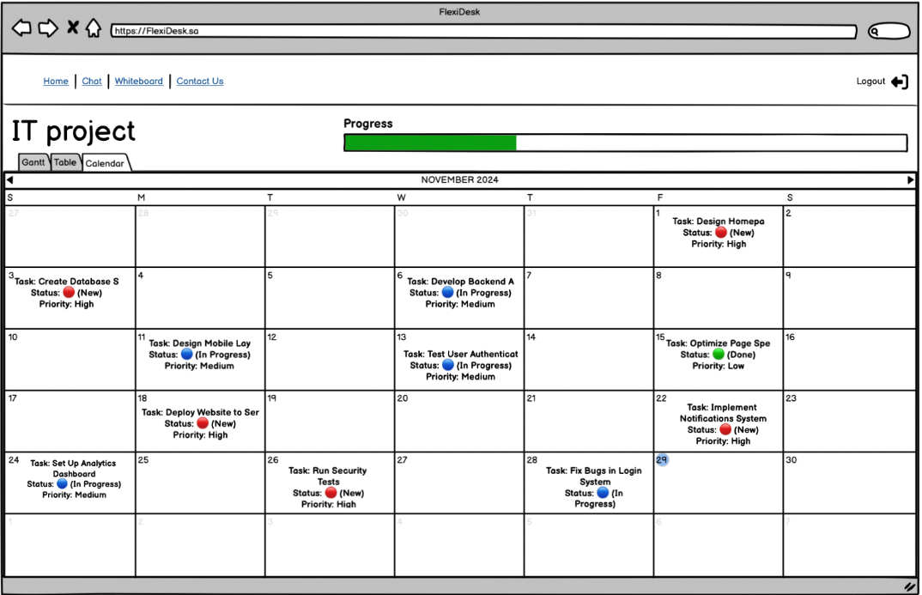

Figure 16 Project page "calendar"

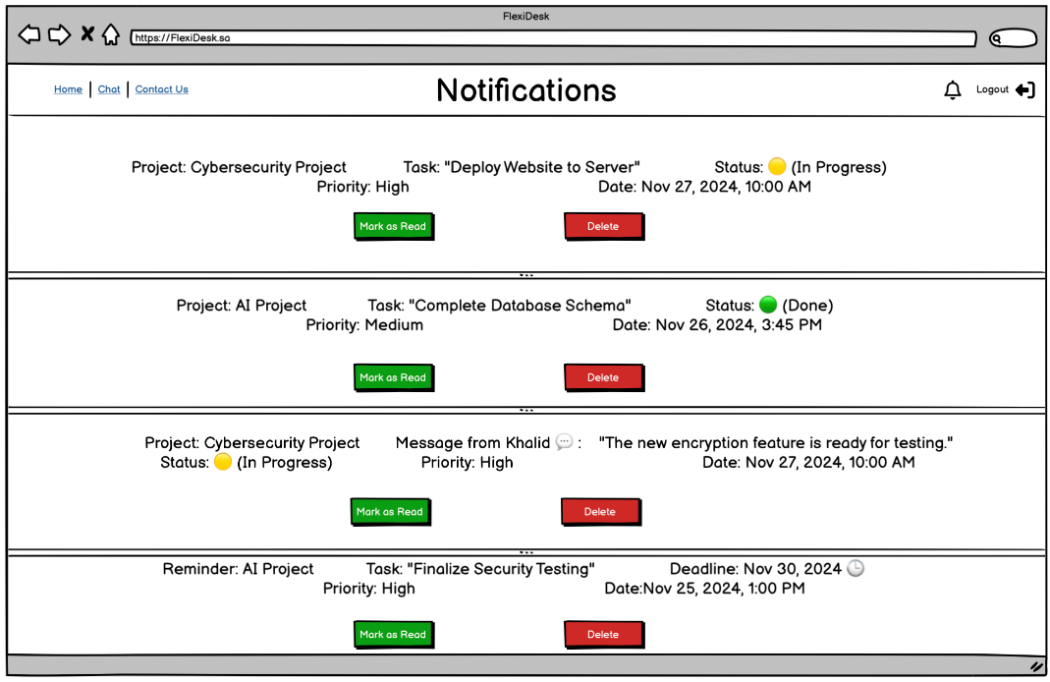

Figure 17 Notification page

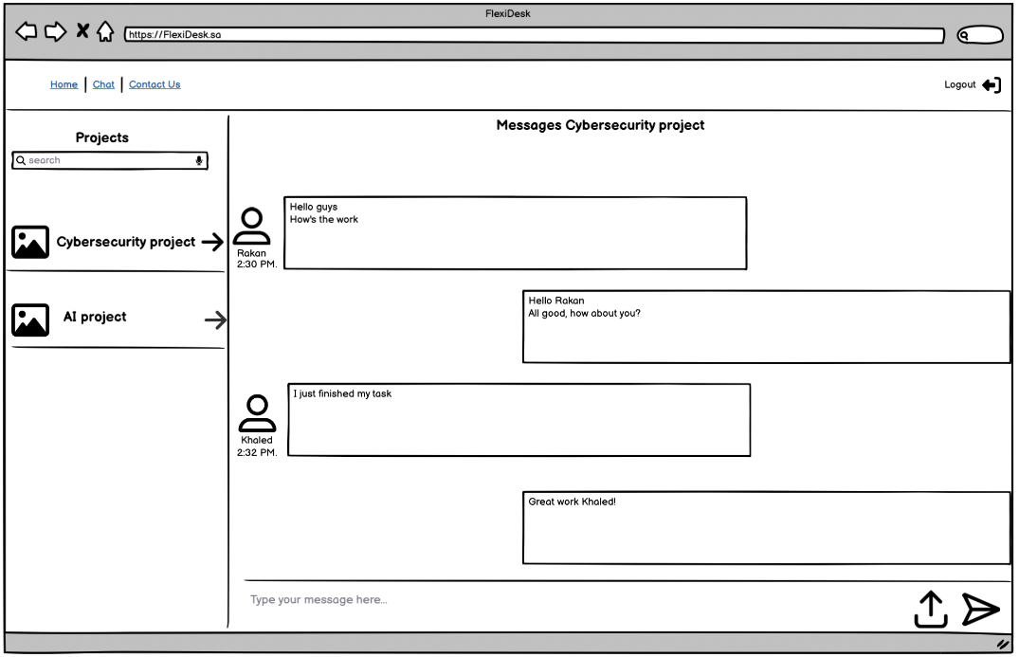

Figure 18 Discussion Page

**4.4.4 Objects and Components Table**

The following table 23 showing "**FlexiDesk**" platform user interfaces objects and

components that show in all the user interfaces.

|  |  |  |
| --- | --- | --- |
| **Object / Component Name** | **Type** | **Description** |
|  | Dropdown Menu | Dropdown to select priorities (High, Medium, Low) for tasks. |
| **Label** | Label | Labels to describe fields like "Project Name," "Deadline," and "Assigned Members." |
|  | Text Input | Text input fields used for entering project names, Passwords, or Email. |
|  | Text Area | Text area used for typing project descriptions. |
|  | Hypertext | Links like "Home", "Contact Us," and "Logout." |
|  | Button | Button to create a new project after filling out the required details. |
|  | Button | Button to add more tasks or members to the project. |
|  | Pop-up | The AI assistant interface provides suggestions during project creation. |
|  | Visual Element | Indicates the progress of task completion within a project. |
|  | Visual Element | Displays tasks and their schedules over time in the form of a timeline. |
|  | Visual Element | Shows task deadlines and project schedules on a calendar. |
|  | Visual Element | Provides a detailed table of tasks, priorities, and statuses. |
|  | Button | Button that redirects users to their respective login pages. |
|  | Button | Button to log out of the platform. |
|  | Button | Redirects the user to the Notification page |
|  | Hypertext | Redirects the user to the chat or discussion area. |
| 🔵 | Icon | Shows that the task is in progress |
| 🔴 | Icon | Shows that the task is not started. |
| 🟢 | Icon | Shows that the task is completed |

Table 23 Objects and Components Table

## System Architecture

This section provides a detailed overview of the system architecture for **FlexiDesk**, illustrating its components, processes, and data flows. The architecture uses a structured design to demonstrate how data moves between external entities, internal processes, and data stores, supported by Data Flow Diagrams (DFD) for clarity.

### Architectural Design Approach

The system architecture for FlexiDesk is modeled using a **top-down design approach**. The **Level Zero DFD** provides a high-level overview of the system as a single process, while the **Level One DFD** breaks it down into sub-processes to show detailed workflows.

### Architectural Design

This section will provide data flow diagram level zero and one.

#### Data Flow Diagram Level Zero

The **Level Zero DFD** provides a high-level view of the FlexiDesk system, depicting it as a single process interacting with external entities: the **Project Manager** and the **Team Member**. It highlights the key data flows between the system and these entities.

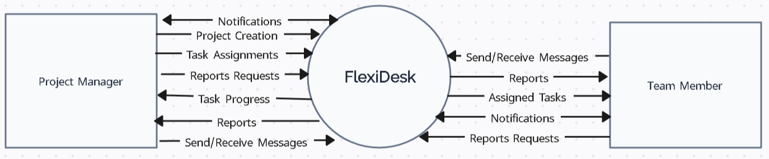

Figure 19 Level Zero DFD

#### Data Flow Diagram Level One

The **Level One DFD** breaks the FlexiDesk system into key processes and data stores. It shows detailed interactions and workflows, specifying how data moves internally between processes and externally to/from entities.

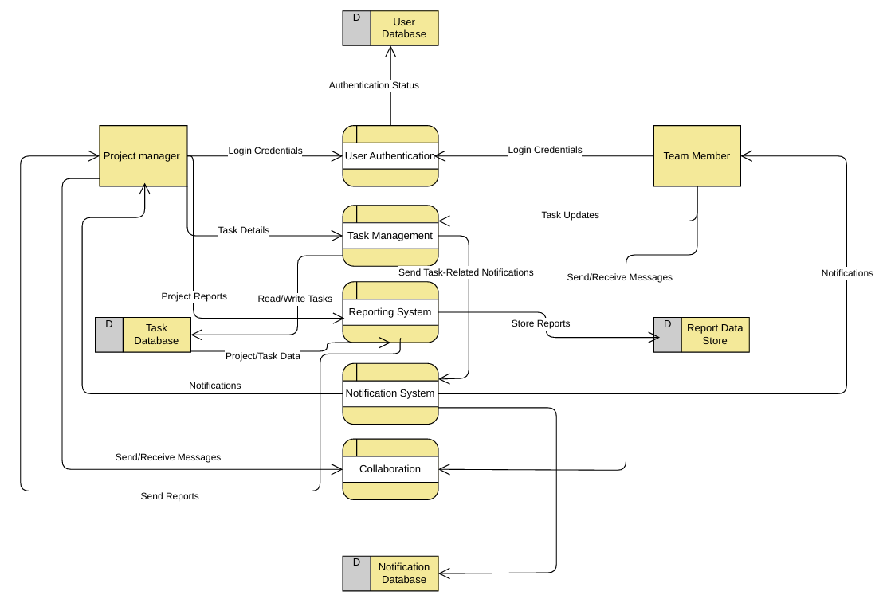

Figure 20 Figure Level One DFD

## Data Design

An overview of the system's data structure is given in this section. It shows how data is arranged and connected by outlining the main entities and their characteristics. A database schema diagram offers an organized depiction of the data storage and retrieval procedures, whereas an entity relationship diagram (ERD) shows the links between entities. When combined, these elements provide a comprehensive overview of the data management framework of the system.

### Data Description

The main entities in the FlexiDesk platform together and their characteristics are thoroughly described in the following tables.

#### Database Tables

##### Users Table

* **Purpose**: Stores information about all users, including project managers and team members.
* **Attributes**:

|  |  |  |  |  |
| --- | --- | --- | --- | --- |
| **Field Name** | **Type** | **Length** | **Primary Key** | **Foreign Key** |
| **userID** | INT | 10 | Yes | No |
| **name** | VARCHAR | 255 | No | No |
| **email** | VARCHAR | 255 | No | No |
| **password** | VARCHAR | 255 | No | No |
| **role** | ENUM | - | No | No |
| **profileImage** | BLOB | - | No | No |

Table 24 Database Tables: Users Table

##### Projects Table

* **Purpose**: Tracks all project-related information managed within the system.
* **Attributes**:

|  |  |  |  |  |
| --- | --- | --- | --- | --- |
| **Field Name** | **Type** | **Length** | **Primary Key** | **Foreign Key** |
| **projectID** | INT | 10 | Yes | No |
| **title** | VARCHAR | 255 | No | No |
| **description** | VARCHAR | 4000 | No | No |
| **startDate** | DATE | - | No | No |
| **endDate** | DATE | - | No | No |
| **managerID** | INT | 10 | No | Yes |

Table 25 Database Tables: Projects Table

##### Tasks Table

* **Purpose**: Tracks tasks associated with projects and their progress.
* **Attributes**:

|  |  |  |  |  |
| --- | --- | --- | --- | --- |
| **Field Name** | **Type** | **Length** | **Primary Key** | **Foreign Key** |
| **taskID** | INT | 10 | Yes | No |
| **projectID** | INT | 10 | No | Yes |
| **assignedTo** | INT | 10 | No | Yes |
| **taskName** | VARCHAR | 255 | No | No |
| **deadline** | DATETIME | - | No | No |
| **status** | ENUM | - | No | No |

Table 26 Database Tables: Tasks Table

##### Notifications Table

* **Purpose**: Logs system-generated notifications sent to users.
* **Attributes**:

|  |  |  |  |  |
| --- | --- | --- | --- | --- |
| **Field Name** | **Type** | **Length** | **Primary Key** | **Foreign Key** |
| **notificationID** | INT | 10 | Yes | No |
| **recipientID** | INT | 10 | No | Yes |
| **type** | ENUM | - | No | No |
| **message** | VARCHAR | 4000 | No | No |
| **createdAt** | TIMESTAMP | - | No | No |

Table 27 database tables: Notifications Table

##### Alerts Table

* **Purpose**: Tracks urgent alerts (e.g., missed deadlines, critical updates) sent to users.
* **Attributes**:

|  |  |  |  |  |
| --- | --- | --- | --- | --- |
| **Field Name** | **Type** | **Length** | **Primary Key** | **Foreign Key** |
| **alertID** | INT | 10 | Yes | No |
| **recipientID** | INT | 10 | No | Yes |
| **priority** | ENUM | - | No | No |
| **details** | VARCHAR | 4000 | No | No |
| **generatedAt** | TIMESTAMP | - | No | No |

Table 28 Database Tables: Alerts Table

##### Reports Table

* **Purpose**: Stores reports generated by the system.
* **Attributes**:

|  |  |  |  |  |
| --- | --- | --- | --- | --- |
| **Field Name** | **Type** | **Length** | **Primary Key** | **Foreign Key** |
| **reportID** | INT | 10 | Yes | No |
| **projectID** | INT | 10 | No | Yes |
| **generatedBy** | INT | 10 | No | Yes |
| **content** | VARCHAR | 4000 | No | No |
| **createdAt** | TIMESTAMP | - | No | No |

Table 29 Database Tables: Reports Table

#### Tables Description

**Users Table**

* Stores personal and login information for all users.
* Includes:
  + userID: Unique identifier for each user.
  + name: Full name of the user.
  + email: Contact email for login and notifications.
  + password: Encrypted password for security.
  + role: User role (e.g., Manager, Member).
  + profileImage: Optional profile picture of the user.
* Linked to:
  + Projects Table: As the managerID (project manager).
  + Tasks Table: As the assignedTo (task assignee).
  + Notifications Table: As the recipientID (notification recipient).
  + Alerts Table: As the recipientID (alert recipient).
  + Reports Table: As the generatedBy (report requester).

**Projects Table**

* Tracks information about all projects.
* Includes:
  + projectID: Unique identifier for each project.
  + title: Name of the project.
  + description: Detailed description of the project.
  + startDate: Project initiation date.
  + endDate: Expected completion date.
  + managerID: Links to the userID in the Users Table for the project manager.
* Linked to:
  + Tasks Table: As the projectID (tasks belonging to the project).
  + Reports Table: As the projectID (reports related to the project).

**Tasks Table**

* Manages all tasks within projects.
* Includes:
  + taskID: Unique identifier for each task.
  + projectID: Links to the Projects Table to associate tasks with their project.
  + assignedTo: Links to the Users Table for the user assigned to the task.
  + taskName: Name of the task.
  + deadline: Deadline for completing the task.
  + status: Current status of the task (e.g., Pending, Completed).
* Linked to:
  + Projects Table: To group tasks under projects.
  + Users Table: To assign tasks to users.

**Notifications Table**

* Logs system-generated notifications sent to users.
* Includes:
  + notificationID: Unique identifier for each notification.
  + recipientID: Links to the userID in the Users Table for the notification recipient.
  + type: Type of notification (e.g., Reminder, Update).
  + message: Content of the notification.
  + createdAt: Timestamp for when the notification was generated.
* Linked to:
  + Users Table: To send notifications to users.

**Alerts Table**

* Handles urgent alerts sent to users, such as missed deadlines or critical updates.
* Includes:
  + alertID: Unique identifier for each alert.
  + recipientID: Links to the userID in the Users Table for the alert recipient.
  + priority: Priority level of the alert (e.g., High, Medium, Low).
  + details: Content of the alert.
  + generatedAt: Timestamp for when the alert was generated.
* Linked to:
  + Users Table: To send alerts to users.

**Reports Table**

* Tracks data for system-generated reports.
* Includes:
  + reportID: Unique identifier for each report.
  + projectID: Links to the Projects Table for the associated project.
  + generatedBy: Links to the userID in the Users Table for the user who requested the report.
  + content: Detailed summary or content of the report.
  + createdAt: Timestamp for when the report was generated.
* Linked to:
  + Projects Table: To associate reports with projects.
  + Users Table: To record which user requested the report.

#### Entity Relationship Diagram

The Entity Relationship Diagram (ERD) visualizes the relationships between the system's key entities, showcasing how data is organized and connected to support the platform's functionality.

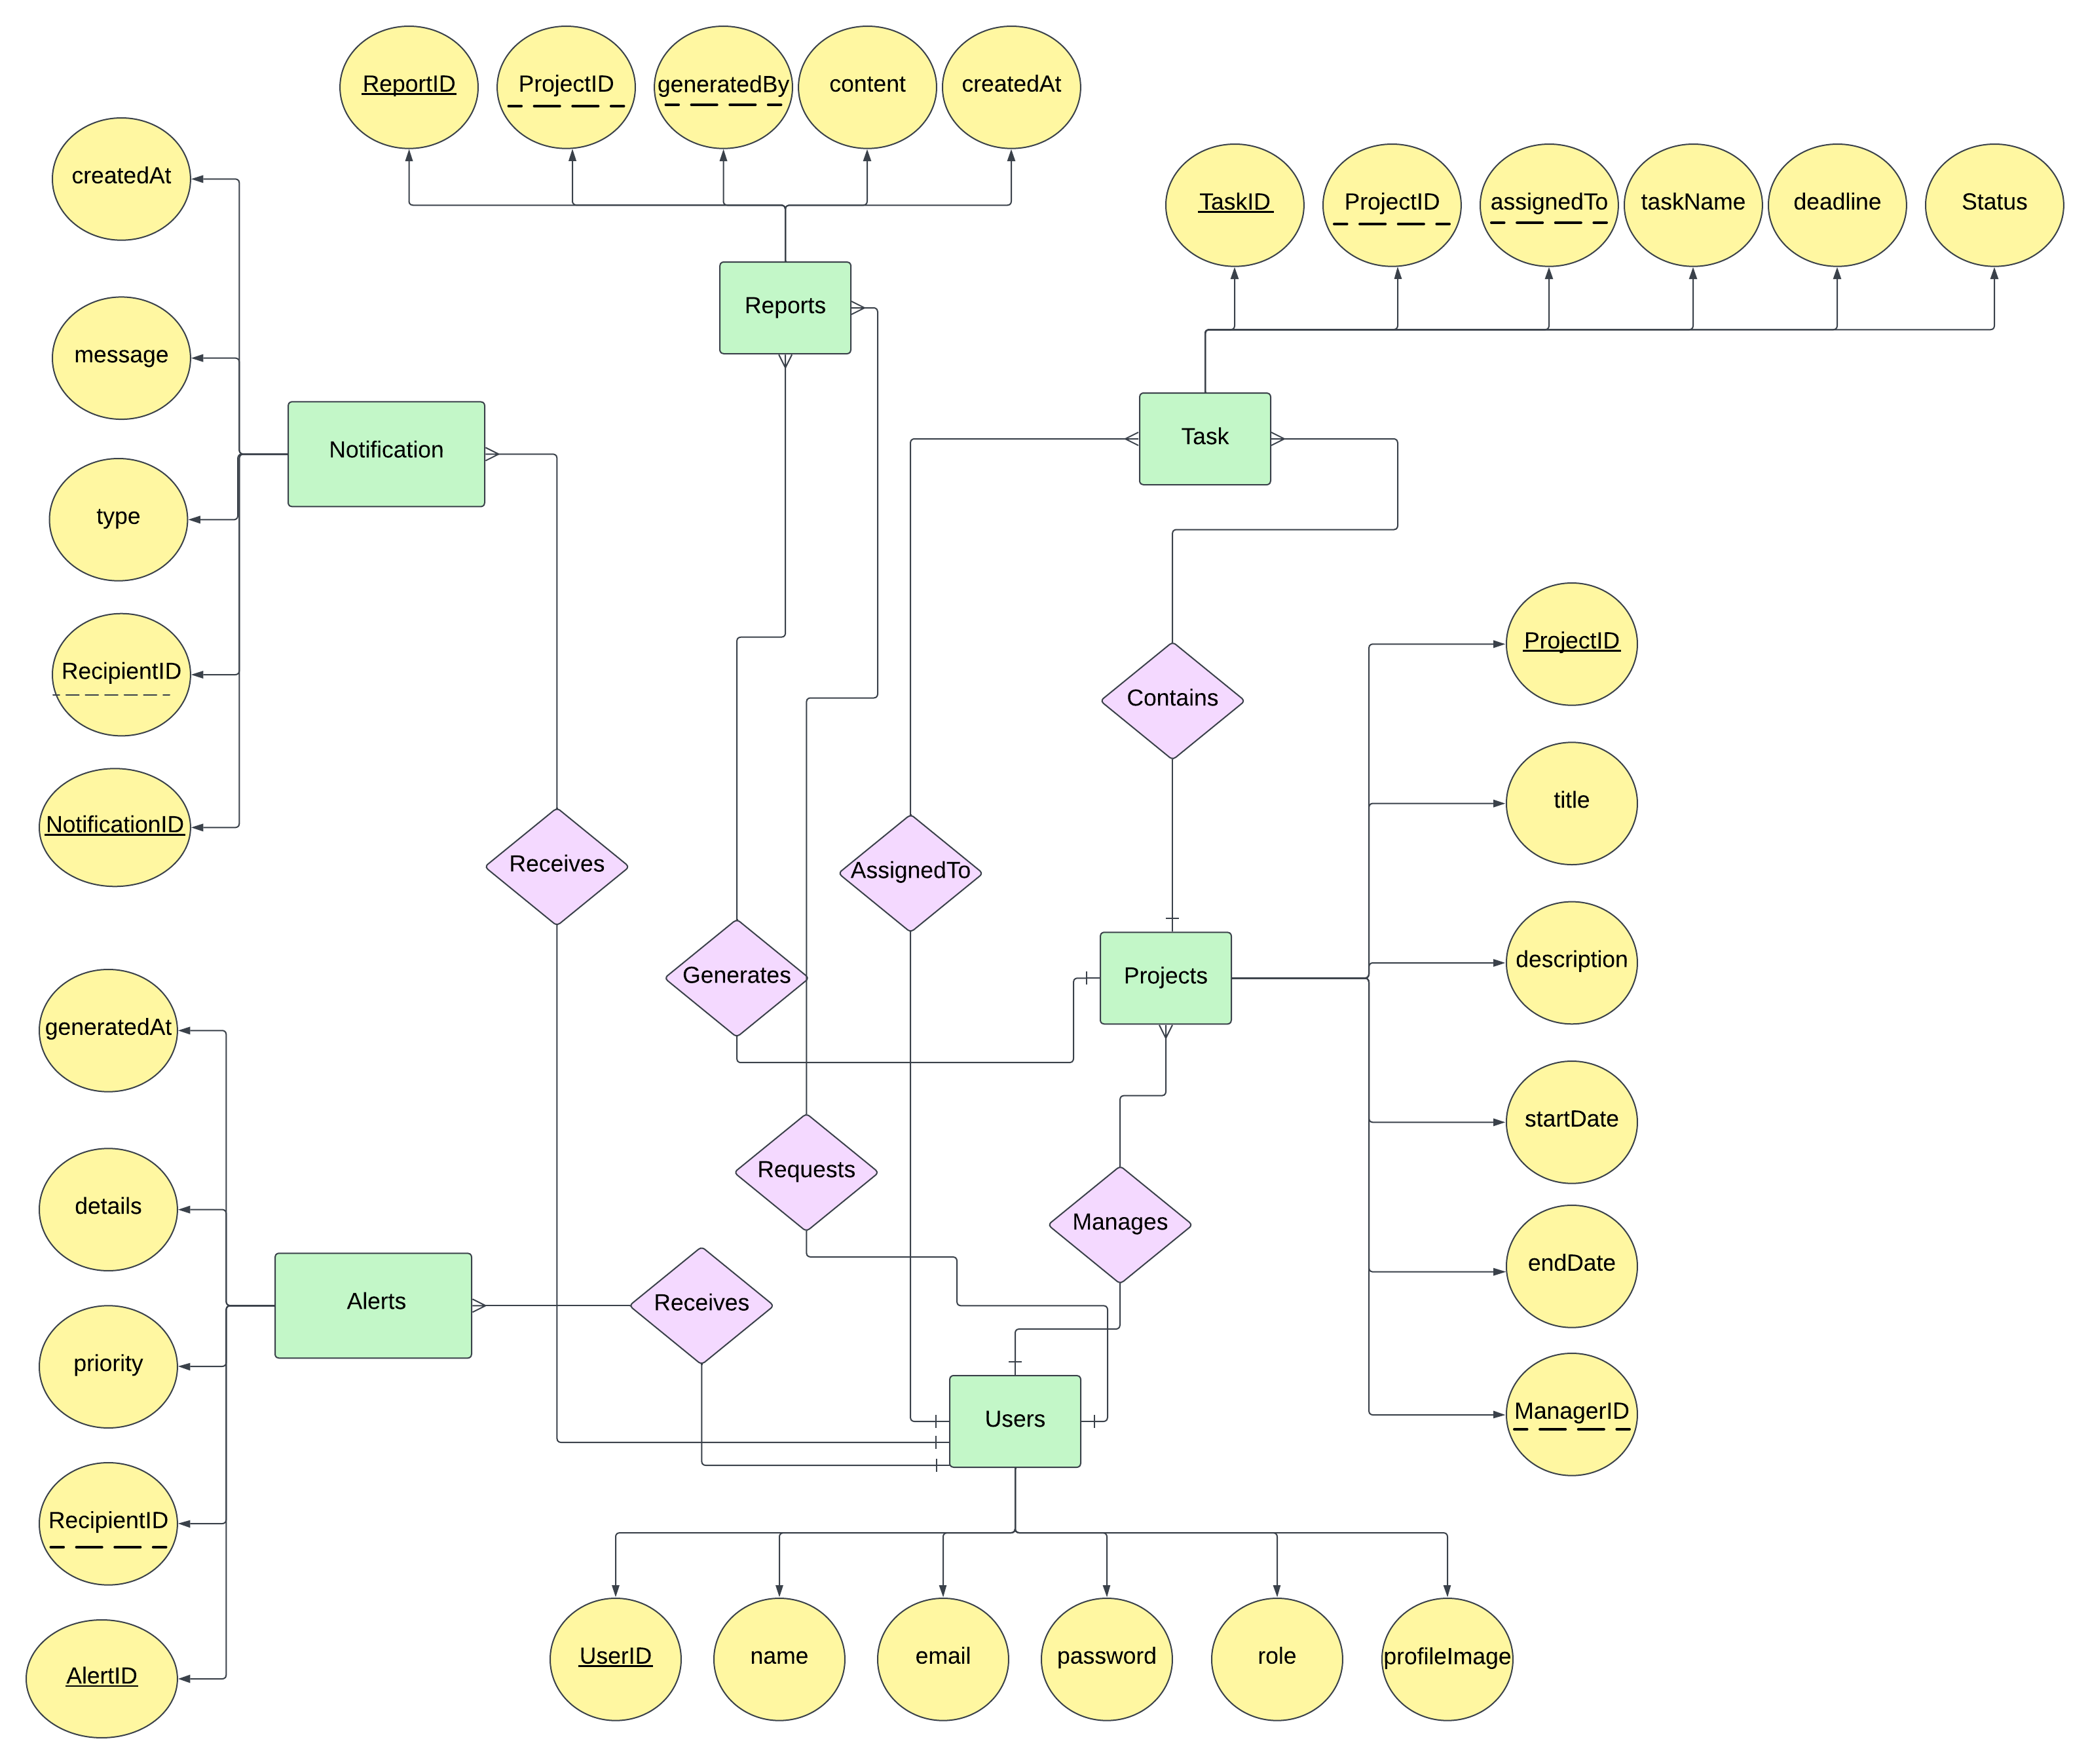

Figure 21 Entity Relationship Diagram

#### Entity Relationships

* **Users to Projects**: One-to-Many (A user can manage multiple projects).
* **Users to Tasks**: One-to-Many (A user can be assigned to multiple tasks).
* **Users to Notifications**: One-to-Many (A user can receive multiple notifications).
* **Users to Alerts**: One-to-Many (A user can receive multiple alerts).
* **Projects to Tasks**: One-to-Many (A project can contain multiple tasks).
* **Projects to Reports**: One-to-Many (A project can have multiple reports).
* **Users to Reports**: One-to-Many (A user can request multiple reports).

#### Database schema

Figure 22 illustrates the database schema of the FlexiDesk platform, outlining the tables, attributes, primary keys, and foreign keys, along with their relationships to facilitate effective data management.

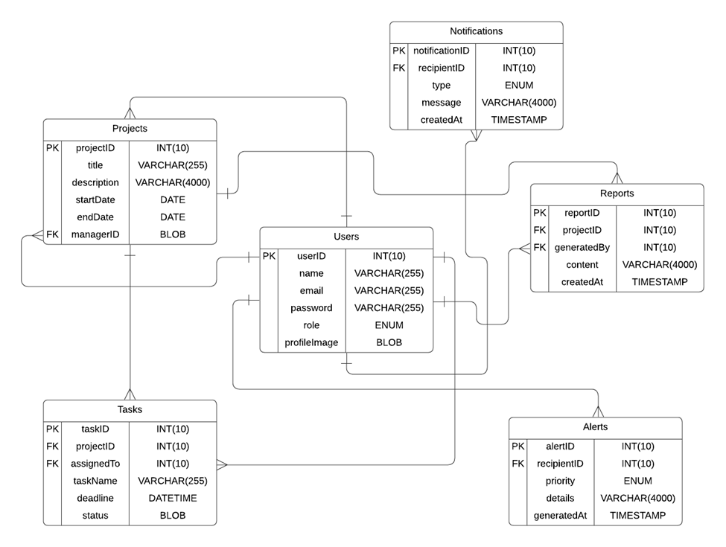

Figure 22 Database schema

### Data Dictionary

**Users Table**

* **userID**: (INT, PK, 10) Unique identifier for each user.
* **name**: (VARCHAR, 255) Full name of the user.
* **email**: (VARCHAR, 255) Contact email address of the user.
* **password**: (VARCHAR, 255) Encrypted password for user login.
* **role**: (ENUM) Role of the user in the platform (e.g., Manager, Member).
* **profileImage**: (BLOB) Profile picture of the user.

**Projects Table**

* **projectID**: (INT, PK, 10) Unique identifier for each project.
* **title**: (VARCHAR, 255) Title or name of the project.
* **description**: (VARCHAR, 4000) Detailed description of the project.
* **startDate**: (DATE) Start date of the project.
* **endDate**: (DATE) End date of the project.
* **managerID**: (INT, FK, 10) Links to the userID in the Users table; identifies the project manager.

**Tasks Table**

* **taskID**: (INT, PK, 10) Unique identifier for each task.
* **projectID**: (INT, FK, 10) Links to the projectID in the Projects table; associates the task with a project.
* **assignedTo**: (INT, FK, 10) Links to the userID in the Users table; identifies the user assigned to the task.
* **taskName**: (VARCHAR, 255) Name of the task.
* **deadline**: (DATETIME) Deadline for task completion.
* **status**: (BLOB) Current status of the task (e.g., Pending, Completed).

**Notifications Table**

* **notificationID**: (INT, PK, 10) Unique identifier for each notification.
* **recipientID**: (INT, FK, 10) Links to the userID in the Users table; identifies the recipient of the notification.
* **type**: (ENUM) Type of notification (e.g., Reminder, Update).
* **message**: (VARCHAR, 4000) Content of the notification.
* **createdAt**: (TIMESTAMP) Timestamp indicating when the notification was generated.

**Reports Table**

* **reportID**: (INT, PK, 10) Unique identifier for each report.
* **projectID**: (INT, FK, 10) Links to the projectID in the Projects table; associates the report with a project.
* **generatedBy**: (INT, FK, 10) Links to the userID in the Users table; identifies the user who generated the report.
* **content**: (VARCHAR, 4000) Detailed content or summary of the report.
* **createdAt**: (TIMESTAMP) Timestamp indicating when the report was generated.

**Alerts Table**

* **alertID**: (INT, PK, 10) Unique identifier for each alert.
* **recipientID**: (INT, FK, 10) Links to the userID in the Users table; identifies the recipient of the alert.
* **priority**: (ENUM) Priority level of the alert (e.g., High, Medium, Low).
* **details**: (VARCHAR, 4000) Detailed content of the alert.
* **generatedAt**: (TIMESTAMP) Timestamp indicating when the alert was generated.

## Sequence Diagrams

The following sections present all the use cases in detail in the form of Sequence Diagrams:

### Sequence Diagrams: Sign Up

Figure 23 illustrates the " Sign Up " processes in a sequence diagram format, presenting user’s steps in "FlexiDesk" platform.

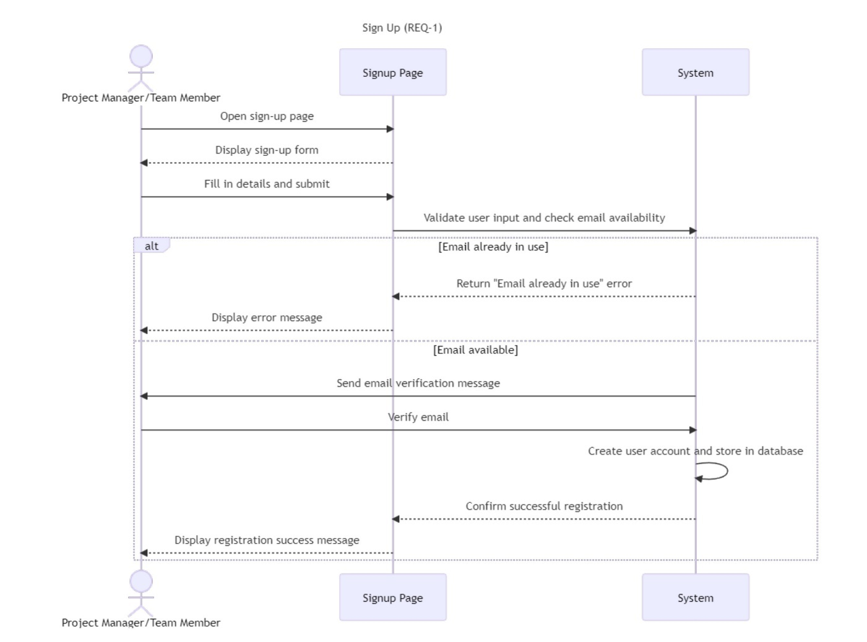

Figure 23 Sequence Diagrams: Sign Up

### Sequence Diagrams: Login

Figure 24 illustrates the " Login " processes in a sequence diagram format, presenting user’s steps in "FlexiDesk" platform.

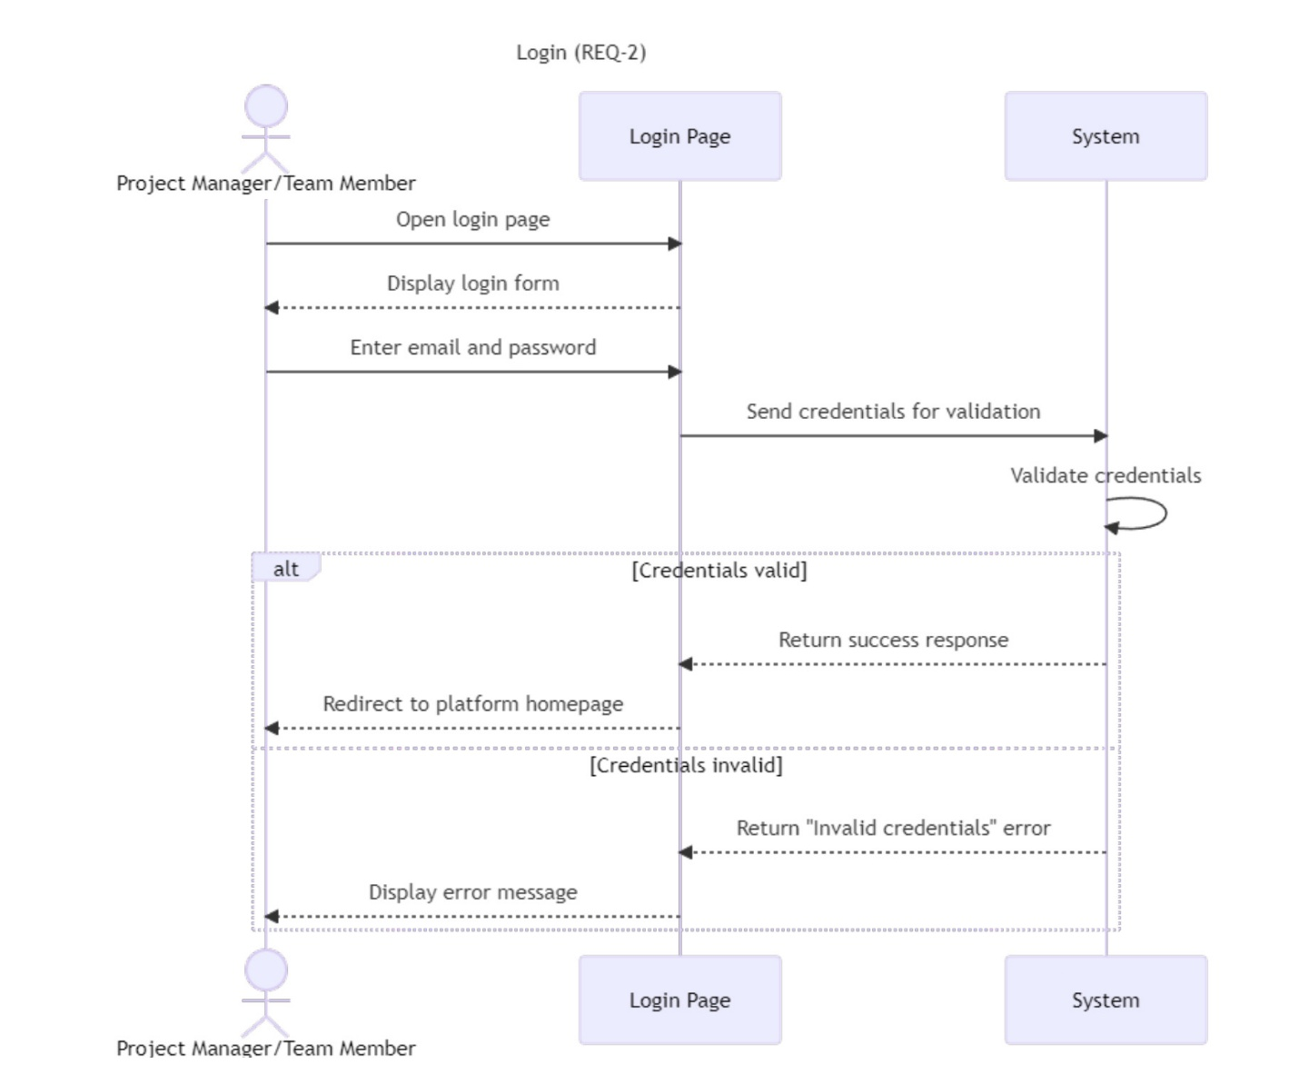

Figure 24 Sequence Diagrams: Login

### Sequence Diagrams: Reset Password

Figure 25 illustrates the " Reset Password " processes in a sequence diagram format, presenting user’s steps in "FlexiDesk" platform.

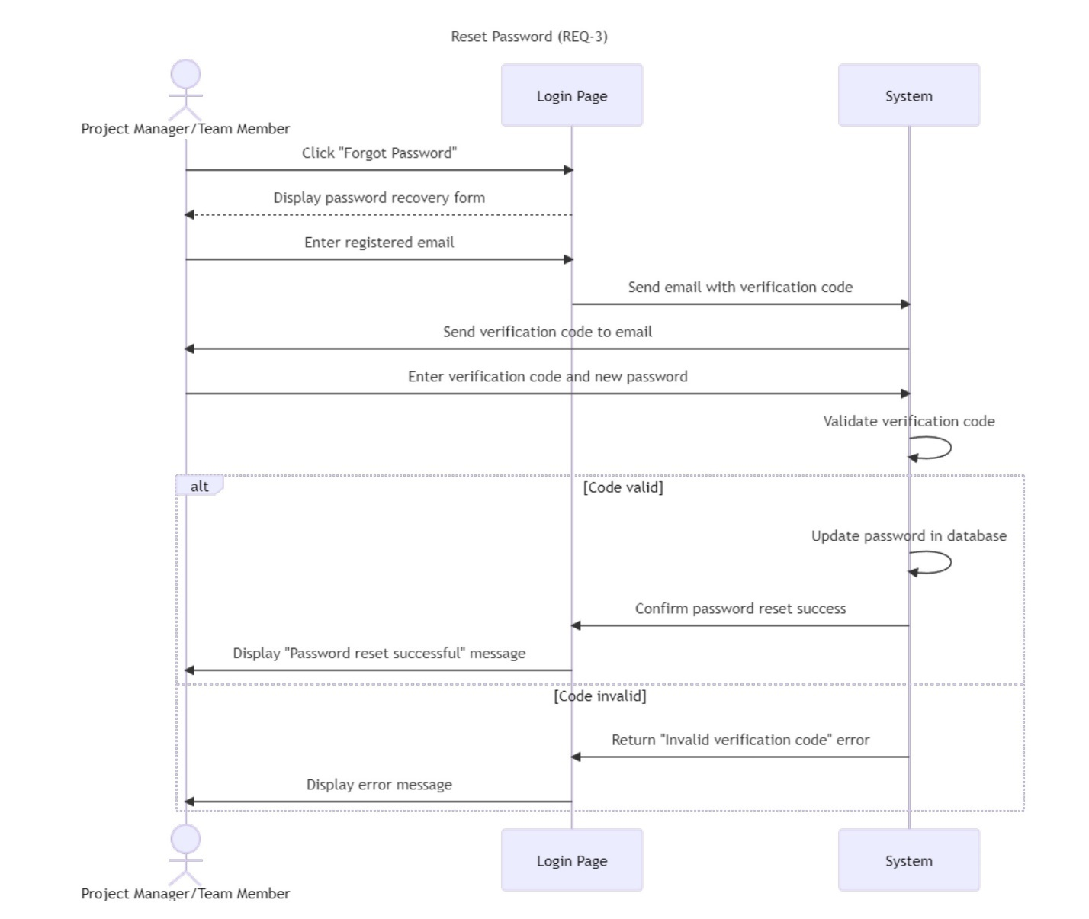

Figure 25 Sequence Diagrams: Reset Password

### Sequence Diagrams: Task and Project Management

Figure 26 illustrates the " Task and Project Management " processes in a sequence diagram format, presenting user’s steps in "FlexiDesk" platform.

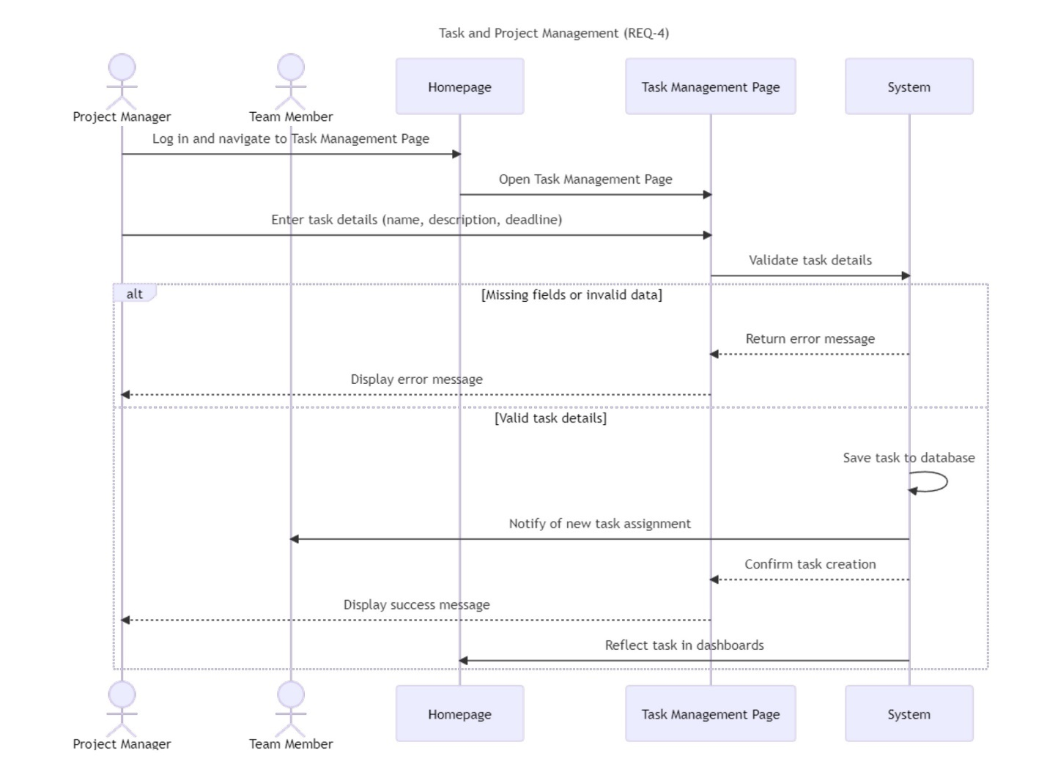

Figure 26 Sequence Diagrams: Task and Project Management

### Sequence Diagrams: Real-Time Collaboration

Figure 27 illustrates the " Real-Time Collaboration " processes in a sequence diagram format, presenting user’s steps in "FlexiDesk" platform.

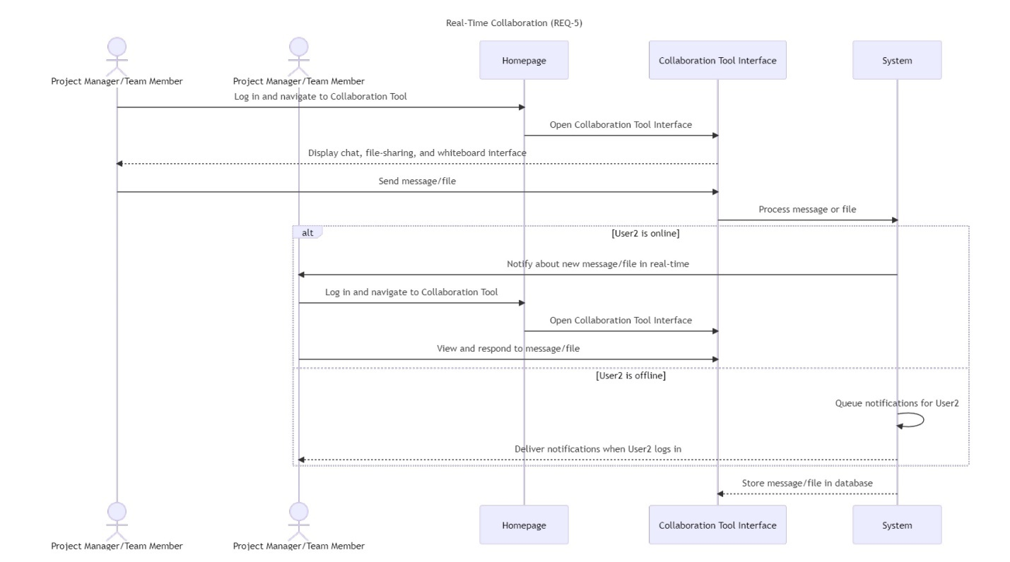

Figure 27 Sequence Diagrams: Real-Time Collaboration

### Sequence Diagrams: Progress Tracking and Dashboards

Figure 28 illustrates the " Progress Tracking and Dashboards " processes in a sequence diagram format, presenting user’s steps in "FlexiDesk" platform.

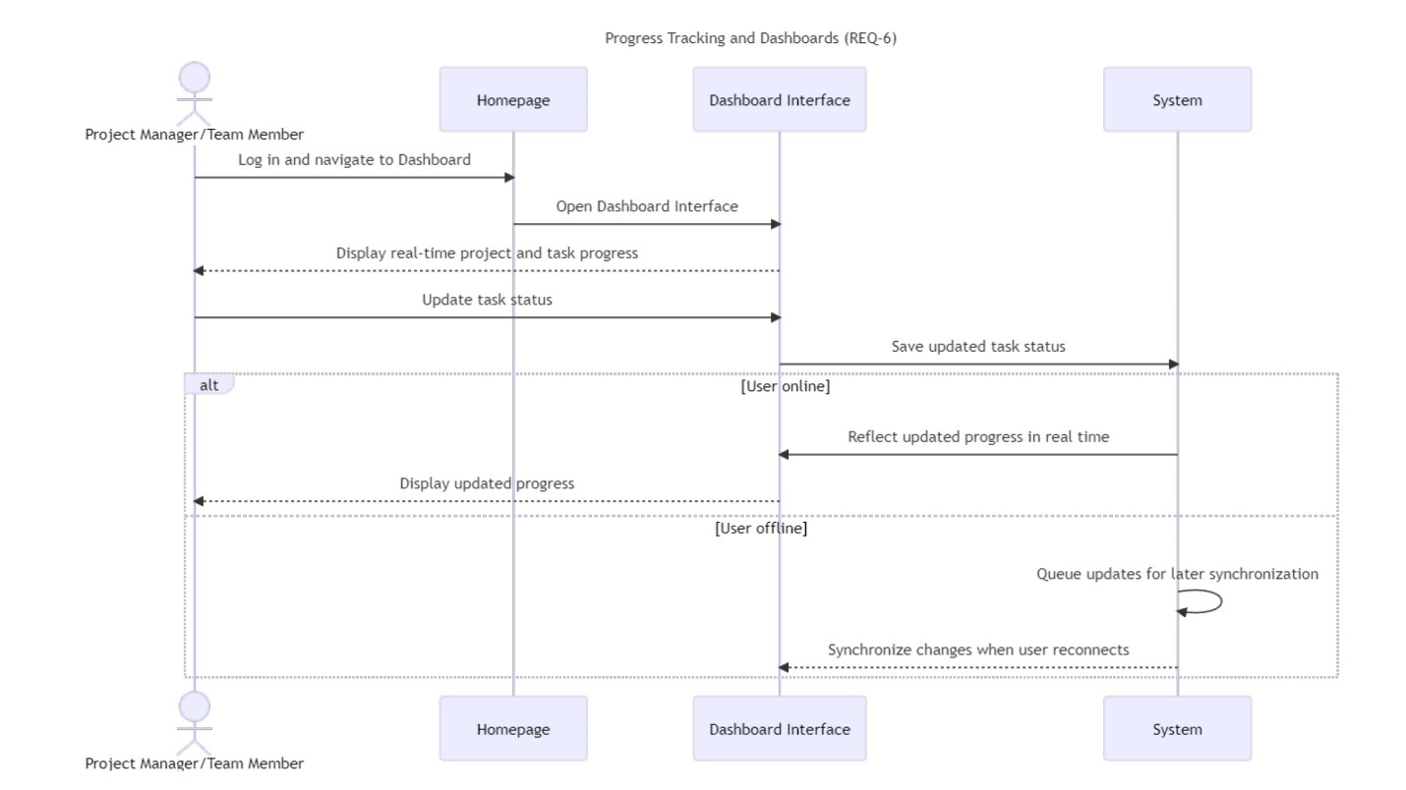

Figure 28 Sequence Diagrams: Progress Tracking and Dashboards

### Sequence Diagrams: Reporting

Figure 29 illustrates the " Reporting " processes in a sequence diagram format, presenting user’s steps in "FlexiDesk" platform.

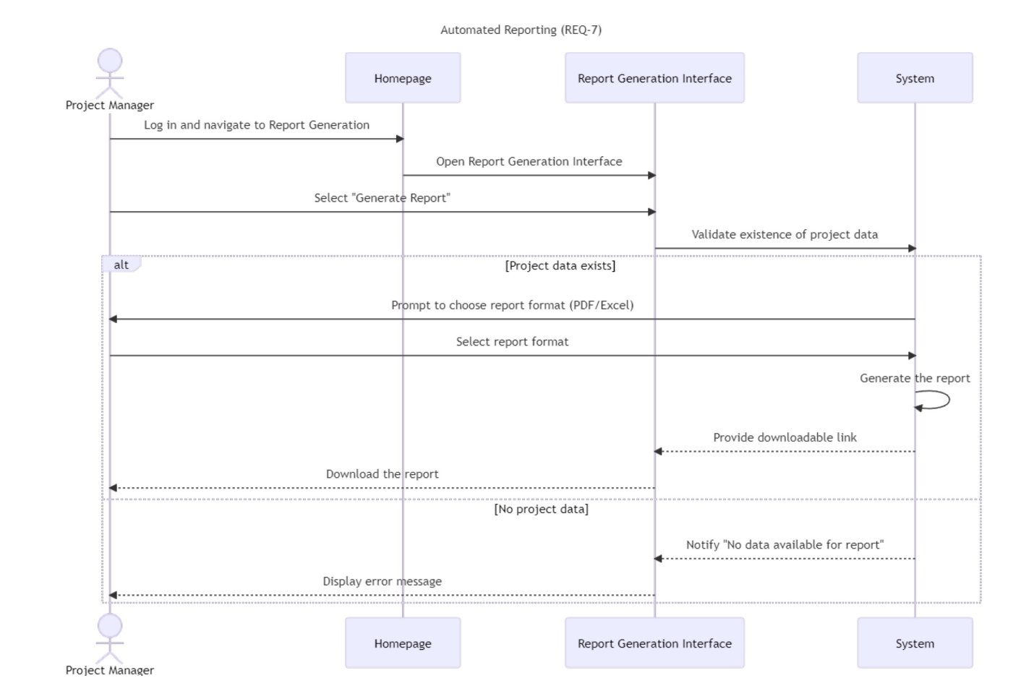

Figure 29 Sequence Diagrams: Reporting

### Sequence Diagrams: Notifications and Alerts

Figure 30 illustrates the " Notifications and Alerts " processes in a sequence diagram format, presenting user’s steps in "FlexiDesk" platform.

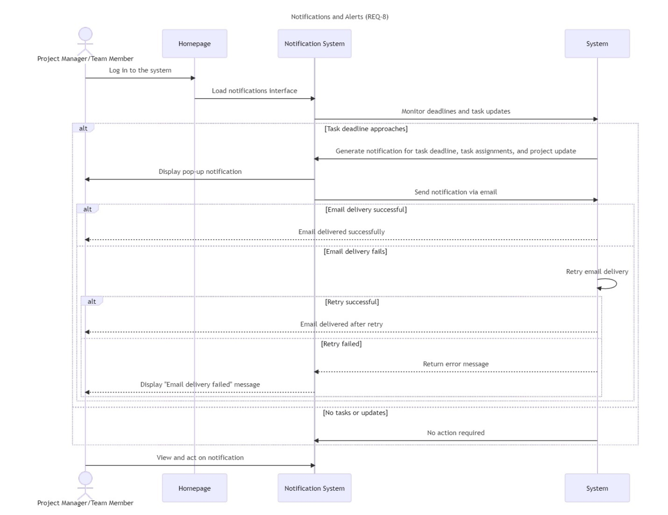

Figure 30 Sequence Diagrams: Notifications and Alerts

### Sequence Diagrams: User Management

Figure 31 illustrates the " User Management " processes in a sequence diagram format, presenting user’s steps in "FlexiDesk" platform.

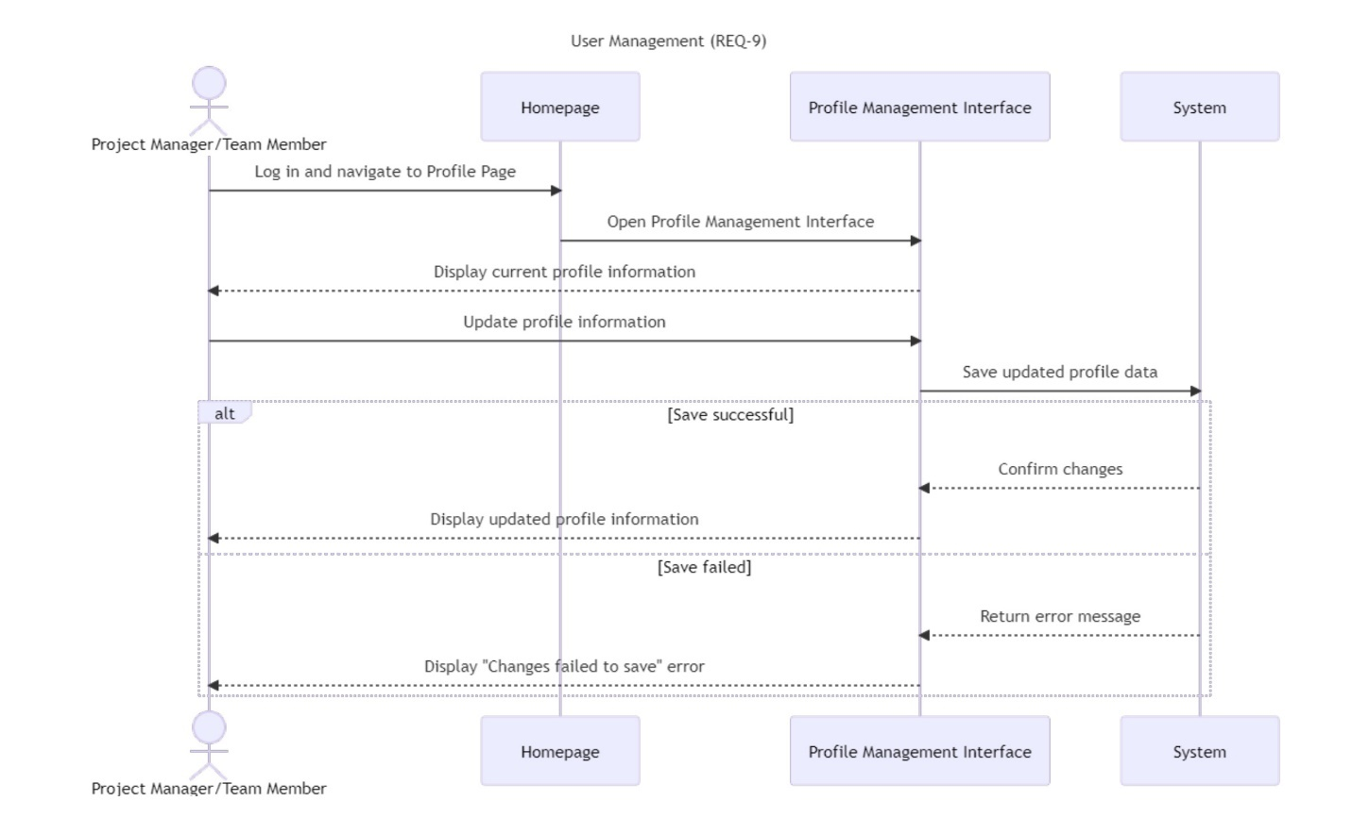

Figure 31 Sequence Diagrams: User Management

## Activity Diagrams

This section provides the Activity Diagrams for **FlexiDesk**, showcasing the workflows for key system features. These diagrams visually represent the sequential flow of actions and decision points in various processes, involving both the Project Manager and Team Members.

### Activity Diagram: Sign Up

Figure 32 illustrates the process of creating a user account, including filling in details, verifying the email, and handling errors if the email is already registered.

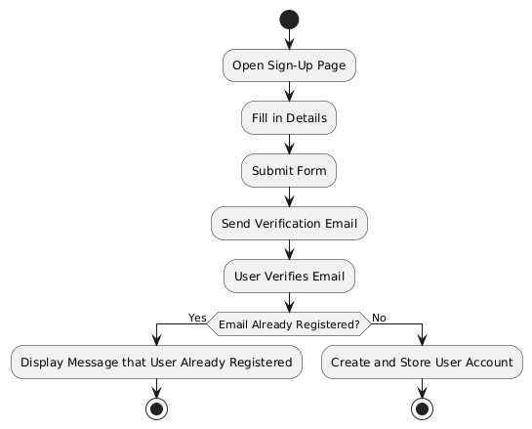

Figure 32 Activity Diagram: Sign Up

### Activity Diagram: Login

Figure 33 illustrates the flow of logging into the platform, validating credentials, granting access, or displaying error message if credentials are incorrect.

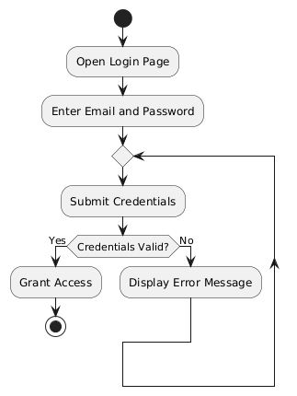

Figure 33 Activity Diagram: Login

### Activity Diagram: Reset Password

Figure 34 describes the steps for users to reset their passwords, from entering their email to verifying a code and setting a new password, with error handling for invalid codes.

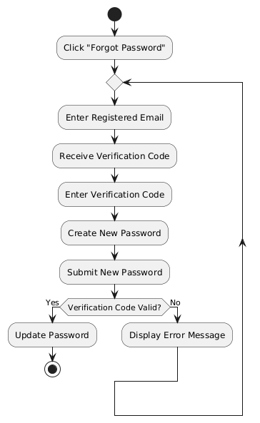

Figure 34 Activity Diagram: Reset Password

### Activity Diagram: User Management

Figure 35 illustrates the process for users to update and save their profile information, including error handling for failed saves.

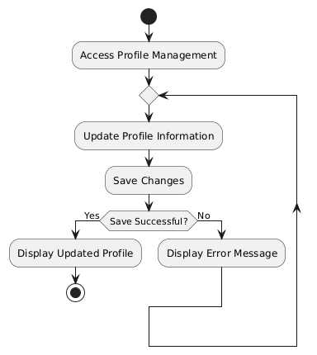

Figure 35 Activity Diagram: User Management

### Activity Diagram: Task and Project Management

Figure 36 shows how tasks are created, assigned, and saved, with provisions for handling errors during task creation.

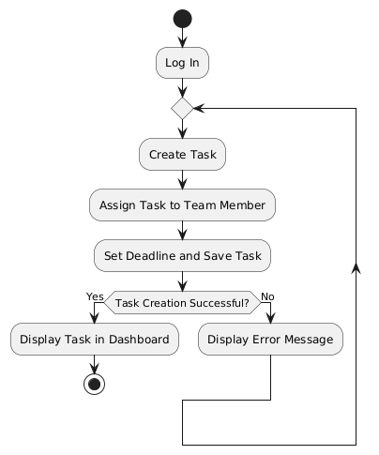

Figure 36 Activity Diagram: Task and Project Management

### Activity Diagram: Real-Time Collaboration

Figure 37 outlines the process of sending messages or files through the collaboration tool, including handling online and offline recipients.

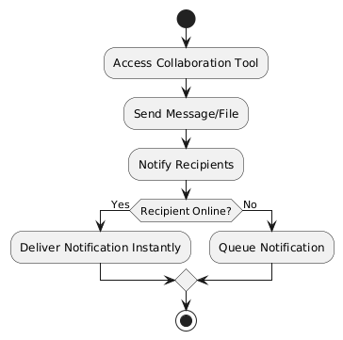

Figure 37 Activity Diagram: Real-Time Collaboration

### Activity Diagram: Notifications and Alerts

Figure 38 explains how notifications are triggered and delivered to users, with retry mechanisms for failed email delivery.

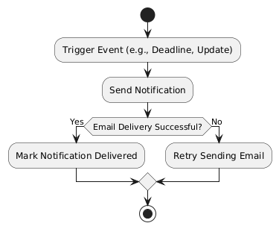

Figure 38 Activity Diagram: Notifications and Alerts

### Activity Diagram: Report Generating

Figure 39 Details the steps to generate and download reports, with error handling if no data is available.

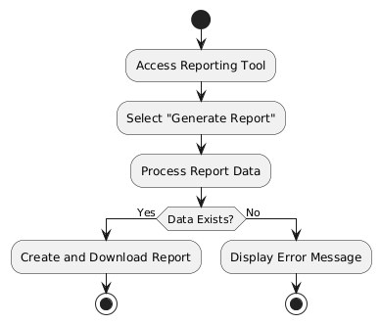

Figure 39 Activity Diagram: Report Generating

### Activity Diagram: Progress Tracking and Dashboards

Figure 40 Highlights how users update task statuses and view real-time progress on dashboards, with queued updates for offline users.

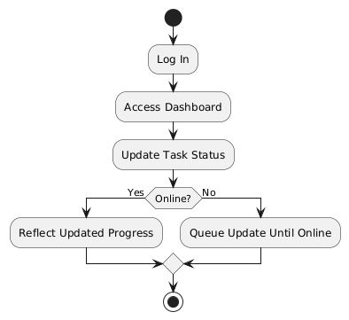

Figure 40 Activity Diagram: Progress Tracking and Dashboards

## Requirement Traceability Matrix

In the following section, all the interfaces and features accessible from each interface will be mentioned.

### General Interfaces

1. Landing Page
2. Homepage
3. Contact Us Page
4. Reset Password
5. New Password Setup Page

### Project Manager Interfaces

1. Login Page
2. Signup Page
3. Homepage
4. Project Creation Page
5. Update Profile Page

### Team Member Interfaces

1. Login Page
2. Signup Page
3. Homepage
4. Update Profile Page

### Requirement Traceability Matrix Table

|  |  |
| --- | --- |
| **Feature** | **Interface Reference (Page Name)** |
| **Sign Up** | Landing Page, Login Page, Signup Page ("Login Page", "Signup Page") |
| **Login** | Landing Page, Login Page ("Login Page") |
| **Reset Password** | Reset Password Page ("Reset Password Page") |
| **Update Profile** | Update Profile Page, Project Manager Interface, Team Member Interface ("Update Profile Page") |
| **Contact Us** | Contact Us Page ("Contact Us Page") |
| **Notifications** | Notification Features ("Notification Features") |
| **Task Management** | Task Management Interface ("Task Management Page") |
| **Progress Tracking** | Project Views, Progress Tracking Bar, Dashboard ("Progress Tracking Bar") |
| **Download Reports** | Viewing Report Page, Project Dashboard ("Viewing Report Page") |
| **Create, Delete, Edit Project** | Project Creation Page ("Project Creation Page") |
| **Team Communication** | Team Communication Interface ("Team Communication Page") |
| **Dashboard Access** | Project Dashboard ("Project Dashboard") |

Table 30 Requirement Traceability Matrix Table

# Conclusion

The development and successful deployment of "**FlexiDesk**" is an important milestone in addressing the challenge of project management that project managers and team members face in different fields. This project also meets academic requirements through applying a practical and innovative solution to current needs in project management towards partial fulfillment for our bachelor's degree in computer information systems (CIS). Work on the development of this system started, and multiple challenges were faced in putting together different technological components and integrating them into a user-friendly interface. It took a lot of planning, and ongoing input from the prototype stage was established. Finally, we have something valuable to offer that will satisfy the team members as well as the project managers.

"**FlexiDesk**" has functionality that allows real-time collaboration, tracking tasks, Artificial Intelligence recommendations on projects, and report generating, all of which reduce needless duplication of effort in project management and boost team output. This project not only highlights our technical skills in trying to enhance project management procedures through creative solutions, but with the guidance of our supervisor, Dr. Saqib Saeed and the support from the College of Computer Science and Information Technology. We are excited about **FlexiDesk's** future development and influence as an effective project management tool. **FlexiDesk** will enable project managers and team members to accomplish their objectives more quickly through improved collaboration, improved workflows, and efficient task management.

# References

[1] D. Hindarto, “The Management of Projects is Improved Through Enterprise Architecture on Project Management Application Systems,” International Journal Software Engineering and Computer Science (IJSECS), vol. 3, no. 2, pp. 151–161, Aug. 2023. [Accessed: Sep. 26, 2024].

[2] T. J. Marion and S. K. Fixson, “The Transformation of the Innovation Process: How Digital Tools are Changing Work, Collaboration, and Organizations in New Product Development*,” Journal of Product Innovation Management, vol. 38, no. 1, pp. 192–215, Aug. 2020. [Accessed: Sep. 28, 2024].

[3] Saad, E.; Hindriks, K. and Neerincx, M. (2018). ‘’Ontology Design for Task Allocation and Management in Urban Search and Rescue Missions’’. In Proceedings of the 10th International Conference on Agents and Artificial Intelligence - Volume 1: ICAART; ISBN 978-989-758-275-2; ISSN 2184-433X, SciTePress, pages 622-629. DOI: 10.5220/0006661106220629. [Accessed: Oct. 3, 2024].

[4] F. Bianconi, “Gantt Charts,” Data and Process Visualisation for Graphic Communication, pp. 175–181, Jan. 2024, doi: https://doi.org/10.1007/978-3-031-57051-3_13. [Accessed: Oct. 3, 2024].

[5] Gjorgjevikj, Dejan & Madjarov, Gjorgji & Chorbev, Ivan & Angelovski, Martin & Georgiev, Marjan & Dikovski, Bojan. (2011). ‘’ASGRT – Automated Report Generation System’’. 369-376. 10.1007/978-3-642-19325-5_38. [Accessed: Oct. 4, 2024].

[6] Microsoft, “Project Management Software,” Microsoft Project, [Online]. https://www.microsoft.com/en-us/microsoft-365/project/project-management-software. [Accessed: 12-Oct-2024].

[7] Trello, “Trello,” [Online]. Available: https://trello.com/. [Accessed: 12-Oct-2024].

[8] Atlassian, “Jira Software,” [Online]. https://www.atlassian.com/software/jira. [Accessed: 12-Oct-2024].

[9] Kingdom of Saudi Arabia, “Personal Data Protection Law,” legal, 2019. [Online]. Available: <https://sdaia.gov.sa/en/SDAIA/about/Documents/Personal%20Data%20English%20V2-23April2023-%20Reviewed-.pdf> [Accessed: Oct. 5, 2024].

[10] “GoDaddy,” GoDaddy website. [Online]. Available: <https://ae.godaddy.com/hosting/web-hosting> [Accessed: 12-10-2024].

[11] Apache Friends, “XAMPP,” [Online]. https://www.apachefriends.org/. [Accessed: 12-Oct-2024].

[12] Microsoft, “Office,” [Online]. https://www.office.com/. [Accessed: 12-Oct-2024].

[13] WhatsApp, “WhatsApp,” [Online]. https://www.whatsapp.com/. [Accessed: 12-Oct-2024].

[14] Discord, “Discord Home Page,” [Online]. https://discord.com/ [Accessed: 12-Oct-2024].

[15] “Lucidchart | Diagramming Powered By Intelligence.” [Online] https://www.lucidchart.com/ [Accessed: 12-Oct-2024].

[16] TeamGantt, “TeamGantt: The Easiest FREE Gantt Chart Maker Online,” [Online] TeamGantt. https://www.teamgantt.com/ [Accessed: 12-Oct-2024].

[17] Xmind Ltd., “Xmind - Full-featured mind mapping and brainstorming tool.,” [Online] https://xmind.app/ [Accessed: 12-Oct-2024].

[18] “Visual Studio Code - Code Editing. Redefined,” <https://code.visualstudio.com/>. [Accessed: Nov. 03, 2024].

[19] "PlantText: UML Diagram Tool," *PlantText*.[Online] <https://www.planttext.com/>. [Accessed: Dec. 5, 2024].